How to Make Whipped Coffee
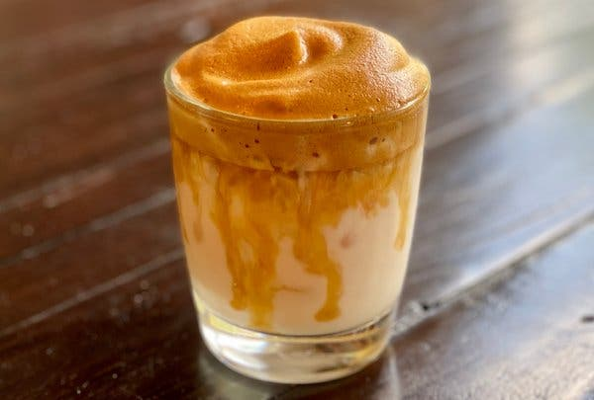

Instant coffee whipped with sugar and water and poured over milk has become an internet sensation in recent months.Credit...Vaughn Vreeland
By Vaughn Vreeland

How to Make Dalgona Coffee
Step 1: To make one drink, combine 2 tablespoons granulated instant coffee, 1/2 tablespoon sugar and 2 tablespoons hot water in a medium bowl. (You can use up to 2 tablespoons sugar for a sweeter drink.)

Step 2: Whip, by hand or with a mixer.

Step 3: Continue mixing until the mixture turns from foamy to frothy to creamy.

Step 4: Spoon the fluffy mixture over milk in a glass filled with ice. (You could also spoon it over warm milk for a hot drink.)

Step 5: Combine and serve.

