WATERMELON CURRY

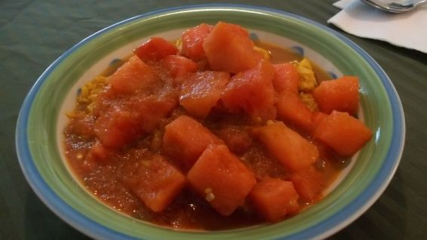

SERVES: 2
YIELD: 3 cups
4cups seedless watermelon, cubed
1 ¹⁄₂ teaspoons red chili powder
¹⁄₄ teaspoon ground turmeric
¹⁄₂ teaspoon ground coriander
1 teaspoon minced fresh garlic
¹⁄₄ teaspoon ground cumin
¹⁄₄ cup coconut milk
2 teaspoons lime juice

DIRECTIONS
Puree 1 cup of the watermelon cubes, chile powder, turmeric coriander, garlic and cumin in a blender until smooth.
Pour puree into a large skillet or wok and bring to a simmer. Allow to simmer for about 5 minutes, so that the contents have reduced by about half.
Stir in coconut milk and lime juice and continue simmering for another minute.
Add the remaining watermelon cubes and simmer until hot through, about 3 more minutes.
Serve over rice.

