Tomato Tart With Fresh Mozzarella and Anchovies

DAVID TANIS
- YIELD4 to 6 servings
- TIME1 1/2 hours
Save To Recipe Box
Print this recipe
EmailShare on PinterestShare on FacebookShare on Twitter
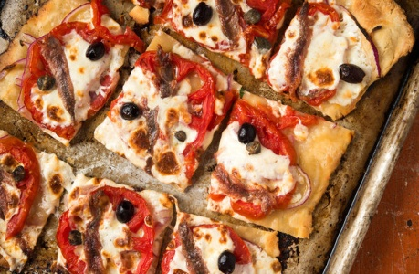
Evan Sung for The New York Times
- Flat bread
- 1 large garlic clove, grated
- 1 cup thinly sliced onion
- 2 large tomatoes, sliced 1/4-inch thick and blotted
- Ground black pepper
- ½ pound fresh mozzarella, thinly sliced
- A few pitted Greek olives, optional
- A few capers, optional
- 8 anchovy fillets, rinsed and patted dry

Nutritional Information

Email Grocery List

PREPARATION
- Make the dough: Put flour and 1/2 teaspoon salt in a mixing bowl. Drizzle in 1/4 cup oil, egg and 1/4 cup cold water, then mix quickly with hands to make a soft dough. If dough seems dry, add more water, 1 tablespoon at a time. Form dough into a rough rectangle, wrap and refrigerate for 30 minutes.
- Heat oven to 425 degrees. On a flour-dusted surface, divide dough in half. Roll out one piece to a rectangle approximately 9 by 12 inches (reserve other piece for future use, or to make a second tart).
- Stir 2 tablespoons olive oil and the garlic together in a small bowl. Put rolled dough on lightly greased baking sheet. Drizzle surface of dough with garlic oil. Scatter onion slices over dough. Arrange tomato slices over dough in one layer without crowding, then season with salt and pepper. Top tomatoes with torn mozzarella slices in one layer. Tuck olives and capers here and there, if using. Drape top of tart with intermittently placed anchovy fillets.
- Bake for 6 minutes on bottom shelf of oven, then transfer to top shelf and bake for another 6 minutes or until nicely browned. Let cool slightly, then cut into squares. Serve warm or at room temperature.

