The Amazing Smoked Swineapple
by Jeff Phillips | Posted on May 25, 2016
14012 Views
# 12
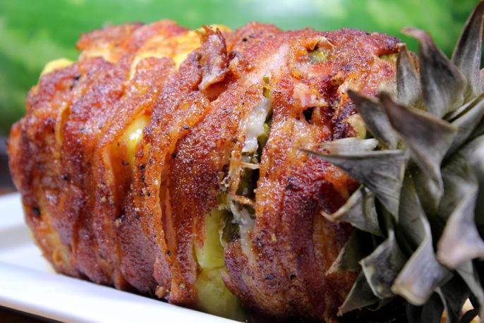
I have received a number of emails over the last few months from readers asking me to take a stab at the smoked swineapple and to give instructions for making one.
If you have not heard about this or seen one of these it is simply a pineapple peeled and cored out, stuffed with pork, wrapped in bacon and smoked long enough to cook the meat (if required) and crisp up the bacon.
Here's my take on the recipe and instructions for what some folks are calling the “Amazing Swineapple”.

Get the Recipes for Jeff’s Rub and Sauce

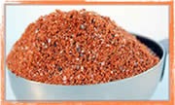
As with all pork, my original rub makes the rib meat more than it could ever be by itself and compliments this swineapple in a way that must be experienced to truly understand. It just works!
I also used my original sauce on the inside and my original rub on the bacon-wrapped outside for some mean layers of flavor.
I promise you’ll love my dry rub/seasoning recipe and my barbecue sauce recipe or you don’t pay!
Reasons to buy: Support the newsletter and the website | Own “the recipes” | Get the email newsletter 100% AD FREE from now on | Includes the Texas style rub recipe | Immediate download + email download
Helpful Information
- Prep Time: 45 minutes
- Cook Time: 3-5 hours
- Smoker Temp: 240°F
- Meat Finish Temp: 150°F
- Recommended Wood: Cherry or Apple
What You’ll Need
- 1-2 ripe pineapples
- 1-2 lbs of pork country style ribs or pork ribs (cooked tender and bones removed)
- 1 lb of bacon
- Jeff’s original rub recipe (purchase recipes here)
Prepare Pork for Stuffing Inside Pineapple
The options are wide open here with the only requirement being you use pork of some kind. This could be ham, de-boned ribs, country style ribs, pulled pork.. you get the idea.
I chose to use country style ribs made from pork butt in mine.
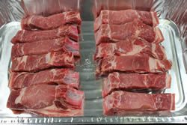
I also chose to precook the meat for safety purposes. I have seen a lot of these made with raw meat but cooking it first is safer and it means that the swineapple is in the smoker for less time.. just enough to crisp the bacon and get some smoke flavor.
My pork country style ribs had some bone here and there so I found all of it and cut it out. fortunately for me, most of it was on the ends.
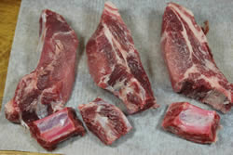
Note: If you purchase boneless country style ribs, it very well may be pork loin meat instead of pork butt and for that reason, it will not be as tender and it can end up a little dry.
Lay all of the country style ribs into a foil pan and coat it with regular yellow mustard to help the rub to stick really well.
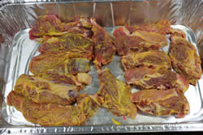
Apply my original rub (purchase recipes here) generously to all sides of the meat then place the meat into the smoker at 225-240°F for about 4 hours or until it reaches 175-180°F.
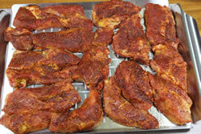
If you are cooking lean meat like pork loin, it only needs to go to 145°F.
Pork ribs like baby backs should be cooked as usual using the 2-2-1 or the 3-2-1 method to make them really tender so you can just pull the bones right out.
Once the meat is done cooking, it is ready to stuff into the pineapple.
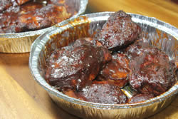
Prep Pineapple for Stuffing
While the meat is cooking, get the pineapple ready.
This includes removing the top, peeling the pineapple, removing the eyes and hollowing out the inside of the pineapple like a mug.
I would be lying if I said this was quick and easy, it takes a bit (or perhaps I am just slow) and I think if you get in a hurry you risk splitting the pineapple.
I opted to leave the bottom intact. I have seen folks hollow out the pineapples like a tube but in my opinion, it makes more sense to only hollow out the insides and leave the bottom in place to keep things from falling out.
This is more difficult but it is worth it in the end.
First remove the top. Slice about ¾ of an inch below the top and set that aside. We'll be using it again.
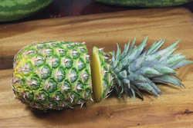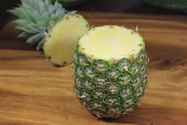
Using a very sharp knife, cut the peel from the pineapple along the sides.
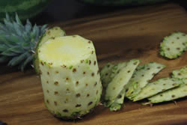
Remove the eyes either by cutting them out one by one or by using the spiral method shown below:
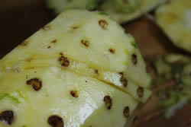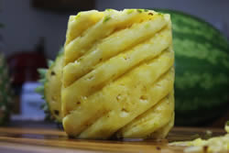
Now hollow out the inside of the pineapple using a sharp knife and some patience.
I used a sharp knife to cut around the perimeter to the depth I wanted. I then carefully whittled out the fruit piece by piece until the entire insides were removed with only a ¾ inch wall around the sides and a ¾ floor on the bottom.
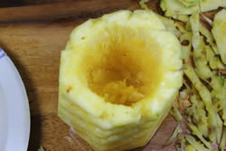
Once the pineapple is hollowed out, it's ready to stuff.
Stuff the Pineapple
Place as much of the meat as possible into the hollow of the pineapple.
Be careful of stuffing to much so it does not try to split.
Drizzle some of my barbecue sauce (purchase recipes here) down into the meat for extra flavor.
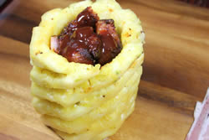
Add some of the crushed pineapple on top of the meat if you like.
Place the top of the pineapple back into position on top of the stuffed pineapple.
Secure Top and Wrap Bacon Around Stuffed Pineapple
Note: some folks use a bacon weave but I opted to just wrap. Both methods work great.
Use 3-4 long wooden skewers to secure the top to the rest of the ensemble.
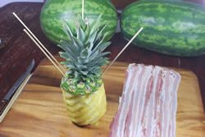
You can then cut the sticks off. I like to leave ½ inch of the stick above the pineapple so I'll have something to grab when I'm ready to pull them out.
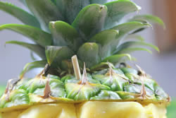
Bacon can be stretched up to nearly twice it's length (if you are careful) and this is perfect for wrapping pineapple since you will most likely need about 16 inches of bacon to make it all the way around the pineapple with a little overlap.
Measure the circumference of your pineapple just to make sure.
Lay down about 6 strips of stretched bacon slightly overlapping on the sides.
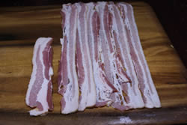
Lay the pineapple onto the bacon and bring the bacon over the top of the pineapple trying to cover it completely.
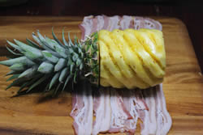
Now roll the pineapple to finish the wrapping process.
Secure the ends of the bacon with small toothpicks.
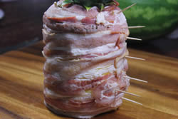
Sprinkle Jeff's original rub (purchase recipes here) all over the outside of the pineapple.
Set the finished pineapple up onto a Weber grill pan or a cookie sheet and it is ready for the smoker.
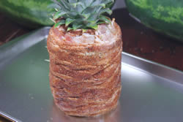
Smoke Swineapple
Set up your smoker for indirect cooking at about 240°F and place the pan with the pineapple into the smoker.
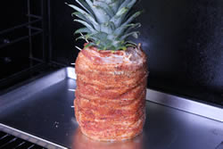
Keep the smoker going for about 3 hours or until the bacon starts to crisp.
When the smoked swineapple is finished remove it from the smoker and admire your artwork.
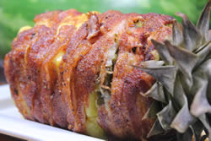
How to Serve the Swineapple
Remove the skewers holding on the top and the toothpicks that held the bacon in place.
Remove the top, slice and serve immediately.
