Sweet-and-Spicy Grilled Vegetables With Burrata

MELISSA CLARK
- YIELD6 to 8 servings
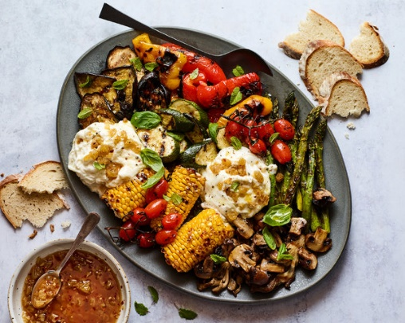

Tip
To make this using a broiler, spread the vegetables on a rimmed sheet pan, drizzle with oil and broil until browned on top, then flip and broil until browned on the other side. The timing will depend on the vegetable, so stick with one kind per baking pan. You’ll need to do this in batches. You can also use a grill pan.

INGREDIENTS

FOR THE SWEET-AND-SPICY SAUCE:
¼ cup chopped raisins, preferably golden, or dried apricots
⅔ cup white wine vinegar or cider vinegar (or a combination)
2 tablespoons honey, plus more to taste
1 tablespoon fish sauce or colatura (optional)
¼ teaspoon red-pepper flakes
Pinch of fine sea salt

FOR THE VEGETABLES (USE ANY OR ALL):
Extra-virgin olive oil
2 to 3 bell peppers, quartered, stems and seeds removed
1 to 2 zucchini or summer squash, sliced diagonally 1/2-inch thick
1 small eggplant, sliced diagonally 1/2-inch thick
2 to 4 ears yellow corn, shucked
8 ounces mushrooms, trimmed and halved or quartered
1 bunch thick asparagus, ends snapped
8 ounces cherry tomatoes, preferably still on the vine

FOR SERVING:
2 small burrata or fresh mozzarella balls, or 2 cups fresh ricotta
Flaky sea salt and freshly ground black pepper
Basil or mint leaves, for serving
Crusty bread slices

PREPARATION
Make the sauce: Put raisins or apricots in a small heatproof bowl. In a small saucepan, combine vinegar, honey, fish sauce or colatura (if using), red-pepper flakes and salt. Bring to a boil, then let simmer until the mixture reduces slightly, about 3 minutes. Immediately pour over the raisins and let cool. Taste and stir in a little more honey if the sauce is too harsh. (Sauce can be made up to 1 week ahead and stored in the refrigerator.)
Prepare the vegetables: Oil the grill grate and light the grill. Have a serving platter at the ready.
Grill the peppers, zucchini, eggplant and corn directly on the grate, in batches if necessary, and turning them as needed. Move them around the grate so they cook evenly. Cook until they are lightly charred, watching them carefully, 5 to 12 minutes, depending on the vegetable.
To grill the mushrooms and asparagus, place them in a grilling basket if you have one, or put directly on the grill. (Arrange the asparagus perpendicular to the grates so they don’t fall through.) Grill, turning as needed, until charred all over, 6 to 10 minutes. Grill the cherry tomatoes, using the vine as a handle if possible, for 1 to 2 minutes, until they start to burst and char slightly. Transfer all the vegetables as they cook directly to the serving platter.
Add the cheese to the platter next to the vegetables. Immediately drizzle everything with some of the sauce, stirring it up to get the raisins, and with olive oil. Sprinkle with flaky sea salt and pepper and scatter the herbs generously on top. Serve the extra sauce and the bread alongside for making crostini with some of the vegetables and more of the tangy sauce.

