Stir-Fried Balsamic Ginger Carrots

TARA PARKER-POPE

- YIELD8 servings

- TIMEAbout 15 minutes
Save To Recipe Box
Print this recipe
Share on Facebook Share on Pinterest Share on Twitter Email
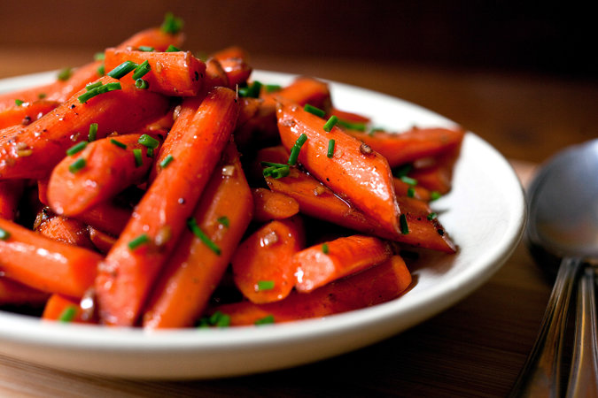
Andrew Scrivani for The New York Times
The carrots need to be cut as uniformly as possible so that all the vegetables cook in the same amount of time. If the carrots are skinny (about 1/2 to 3/4 inch in diameter), simply cut them into 2-inch pieces; if they’re medium (about 1 inch in diameter), cut lengthwise in half before cutting into 2-inch pieces; if they’re large (about 1 1/2 to 2 inches in diameter), quarter lengthwise before cutting into 2-inch pieces. Blanching the carrots reduces the amount of oil necessary to stir-fry. Mince the ginger by hand; if you use a grater or microplane, the ginger will be too wet and will spatter in the oil.
Featured in: Six Steps To A Thanksgiving Stir Fry.
Vegetarian, Vegan, Dairy Free, Gluten Free,Kosher
Cooked

29 ratings

INGREDIENTS
- 1 ¼ teaspoon salt
- 1 ½ pounds carrots, cut diagonally into 2-inch pieces (about 5 cups)
- 1 tablespoon plus 1 teaspoonbalsamic vinegar
- 1 tablespoon dry sherry
- 2 teaspoons soy sauce (low-sodium if desired)
- ¾ teaspoon sugar
- ¼ teaspoon freshly ground pepper
- 2 tablespoons peanut or canola oil
- 2 tablespoons minced ginger
- 2 tablespoons finely choppedchives

Nutritional Information

PREPARATION
- In a 3-quart saucepan, bring 1 1/2 quarts water to a boil over high heat. Add 1/2 teaspoon of the salt and the carrots and return to a full boil, about 5 minutes. Boil for 2 additional minutes. Drain the carrots in a colander, shaking well to remove excess water. Combine the vinegar, sherry and soy sauce in a cup. Combine the sugar, pepper and the remaining 3/4 teaspoon salt in a small dish.
- Heat a 14-inch flat-bottomed wok or a 12-inch skillet over high heat until a drop of water evaporates within a second or two when added to the pan. Swirl in the oil by adding it to the sides of the pan and swirling the pan, then add the ginger and stir-fry no more than 10 seconds, until the ginger is fragrant. Add the carrots and stir-fry for 1 minute, until the carrots are well coated in oil and ginger. Swirl the vinegar mixture into the wok, sprinkle with the sugar mixture, and stir-fry for 1 minute, until the carrots are crisp-tender. Immediately transfer to a serving bowl and sprinkle with chives.

Tip
- Advance preparation: You can make this dish earlier in the day and reheat in a medium oven.

