Spiedies

SAM SIFTON
- YIELD4 to 6 servings

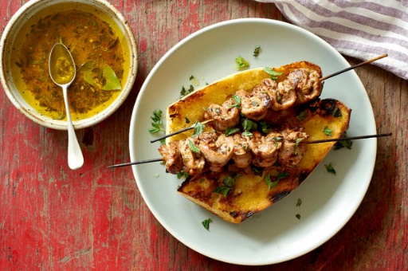
Melina Hammer for The New York Times

Spiedies are a mainstay sandwich of Binghamton, N.Y., and its surrounding boroughs. They’re made of meat marinated for a long time in what amounts to Italian dressing, then threaded onto skewers, grilled, and slid into a cheap sub roll, sometimes with a drizzle of fresh marinade or hot sauce. The recipe that follows calls for beef, but pork or venison can be used almost interchangeably. Marinate for a long time: a full 24 to 36 hours is not uncommon, and results in chunks of meat that are so deeply flavored that they taste great even when slightly overcooked. (If you use chicken, however, reduce the length of time in the marinade, since the meat starts to break down after 12 hours or so.) Serve the spiedies with an additional drizzle of lemon juice and olive oil, on top of Italian bread or alongside rice.

FOR THE SPIEDIES:
- 2 to 3 pounds beef, pork, venison, lamb or chicken, cut into small cubes, at most 1-inch square
- Kosher salt and black pepper, to taste

FOR THE MARINADE:
1 cup extra-virgin olive oil
¾ cup red wine vinegar
Zest of 1 lemon
¼ cup freshly squeezed lemon juice (about 2 lemons)
4 cloves garlic, peeled, smashed and roughly chopped
1 bay leaf
1 tablespoon thyme leaves
1 tablespoon oregano leaves
1 tablespoon basil leaves, rolled and chopped into chiffonade
1 teaspoon granulated sugar
1 teaspoon kosher salt
1 teaspoon freshly cracked black pepper
1 teaspoon red pepper flakes, or to taste
Add to Your Grocery List
Make the marinade: Whisk together all the ingredients in a large bowl.
Add the meat to the marinade and cover tightly, or place into large, re-sealable plastic bags and refrigerate for 24 to 36 hours (or 10 to 12 hours for chicken).
Build a fire in your grill, leaving about 1/3 of grill free of coals, or set a gas grill to high.
Remove the meat from its marinade and thread onto metal skewers, or wooden ones that you have soaked in water for 30 minutes or so. The chunks can be placed quite close together. Sprinkle with salt and pepper.
When coals are covered with gray ash and fire is still quite high (you can hold your hand 5 inches above coals for only a couple of seconds), place the skewers of meat directly over the flames. Allow the meat to cook, undisturbed, for approximately 3 to 4 minutes, then use kitchen tongs to turn them over and repeat on the other side. Continue turning the skewers every couple of minutes until the meat is deeply crisp at its edges, and cooked entirely through, approximately another 5 to 7 minutes. (Remove them to the cool side of the grill if they begin to burn, and cover the grill to allow them to smoke-roast until finished; this is much less likely to happen on a gas grill.)
Allow the spiedies to rest on a cutting board for a few minutes, then remove the meat from the skewers onto cut hero rolls or a plate. Serve with hot sauce on the side.

