Sicilian Involtini With Ham and Cheese

NY Times Cooking
- YIELD4 to 6 servings

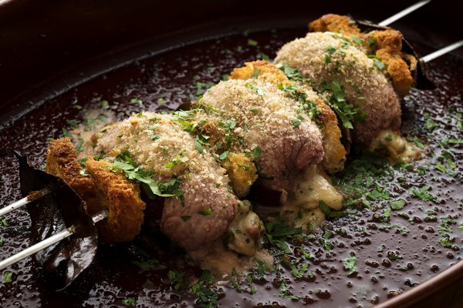
Karsten Moran for The New York Times

8 veal scallops (about 3 ounces each), sliced or pounded to 1/8-inch thickness
Salt and pepper
Extra-virgin olive oil
½ cup finely diced red onion, plus 1 small onion, cut into rough 1-inch squares
6 slices day-old peasant bread, roughly chopped in 1/4-inch pieces (about 2 cups)
4 ounces prosciutto cotto (cooked ham), cut into 1/4-inch cubes (about 3/4 cup)
2 eggs, beaten
4 ounces caciocavallo or Provolone cheese, diced small (about 3/4 cup)
2 tablespoons chopped fresh marjoram
¼ cup chopped parsley
Bay leaves, fresh or dried
10 slices bread, cut into 2-by-3-inch rectangles
1 cup dry homemade bread crumbs
Pinch of dried oregano

Season veal scallops on both sides with salt and pepper, and set aside. Heat oven to 400 degrees.
In a skillet set over medium heat, heat 2 tablespoons olive oil. Add onion, season with salt and pepper, and cook, stirring, until softened but not browned, about 5 minutes.
Add bread cubes and ham, and toss well to coat. Cook for 1 minute more, then transfer mixture to a bowl and let cool to room temperature. Season with salt and pepper. Stir in eggs, cheese, marjoram and parsley.
Place 2 to 3 tablespoons of filling on each veal slice, depending on size. Fold sides over the filling and roll each piece into a little parcel. Set aside, seam-side-down.
Thread the parcels onto skewers: Start with a rectangle of bread, a bay leaf and a strip of red onion. Next, place a meat parcel. Continue in this fashion until skewer is full — you’ll get 3 or 4 parcels per skewer. Secure by threading another skewer parallel to the first one. Place completed skewers on a baking sheet or in a dish.
Dip a brush in olive oil and generously daub the involtini all over. Sprinkle generously with bread crumbs. Add a small sprinkle of oregano. Bake for 20 to 30 minutes, until meat is cooked through and crumbs are golden. To serve, transfer the meat rolls to a platter.

