Rosemary-Honey Almond Tart

By Yewande Komolafe
- YIELD8 to 10 servings
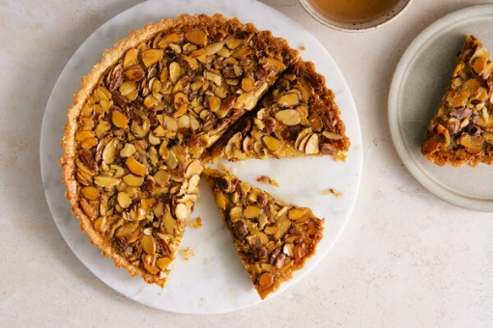

You can do several steps ahead of time, or the whole tart can be prepared and baked, then cooled, wrapped and stored in the refrigerator for up to 3 days or in the freezer for up to 1 month.
- The tart dough and the filling can be made ahead and refrigerated separately for up to 1 week. Stir the filling before pouring into the tart shell to evenly distribute the

FOR THE CRUST:
- 6 tablespoons/75 grams cold unsalted butter, cut into 1/2-inch cubes, plus more for the pan
- 1 ½ cups/205 grams all-purpose flour, plus more for rolling the dough
- ⅓ cup/63 grams granulated sugar
- 1 tablespoon freshly grated lemon zest
- 1 teaspoon kosher salt (Diamond Crystal)
- 2 large egg yolks
- ¼ cup/58 milliliters cold water

FOR THE FILLING:
- ½ cup/144 grams honey, such as wildflower
- 6 tablespoons/75 grams unsalted butter, cut into ½-inch cubes
- ⅓ cup/63 grams granulated sugar
- 4 small rosemary sprigs
- 1 teaspoon kosher salt (Diamond Crystal)
- 1 large egg plus 2 large egg yolks
- ½ cup heavy cream
- 1 ¼ cups/156 grams sliced almonds
Add to Your Grocery List

PREPARATION
- Prepare the crust: Generously butter a 10-inch round (3/4- to 1-inch deep) fluted tart pan. In a medium bowl, combine the flour, granulated sugar, lemon zest and salt. Working quickly, rub or cut the cold butter into the dry mixture using your fingers or a pastry cutter until the pieces are the size of small pebbles. (Alternatively, use a food processor to pulse the dry ingredients with the butter.) Add the egg yolks and the cold water. Using your hands, combine just until the dough comes together in clumps. Gather dough into a ball; flatten into a disk, wrap in plastic wrap and refrigerate until firm, at least 30 minutes or up to 1 week (see Tip).
- While the dough chills, prepare the filling: In a small pot set over medium-low, combine the honey, rosemary sprigs, sugar, butter and salt. Stir frequently until the butter melts and the sugar dissolves, 6 to 8 minutes. Remove from the heat and cool for at least 10 minutes. Whisk the egg, yolks and cream in a liquid measuring cup. Remove the rosemary sprigs from the honey and whisk the egg mixture into the honey mixture until fully blended. Stir in the almonds. The filling can be covered and refrigerated for up to a week (see Tip).
- Using a floured rolling pin, roll out chilled dough between two sheets of parchment paper or on a lightly floured surface into a 12-inch round. To transfer to the tart pan, roll the dough around the rolling pin, then unroll it over the pan without stretching it. Gently press the dough into the fluted sides and, using a pair of kitchen scissors or a sharp knife, trim any overhang to 1/4 inch above the pan. Refrigerate the tart shell until firm, at least 20 minutes. Heat oven to 375 degrees while the dough chills.
- Line the tart dough with parchment paper and fill with pie weights or dried beans. Bake until the crust is lightly browned along the edges and beginning to firm up, about 18 minutes. Remove the pie weights and parchment and bake for another 5 minutes to lightly brown the edges. Press down the bottom surface with the back of a spoon if the crust bubbles. Allow the crust to cool completely before filling. Lower the oven temperature to 350 degrees.
- Place the tart pan on a rimmed baking sheet and carefully pour the filling into the cooled tart shell. Bake until the filling is set, deep golden brown and jiggles slowly when the pan is moved back and forth, 30 to 35 minutes. Cool the tart completely before slicing. The tart will keep refrigerated for up to 3 days, or can be cooled, wrapped and frozen for up to 1 month. Defrost before serving.

Tip

