Roasted Winter Tomatoes

AMANDA COHEN

- Yield2 to 3 quarts (about 10 cups)
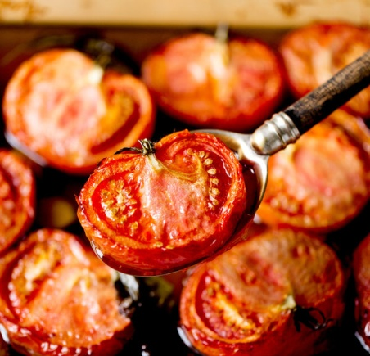

INGREDIENTS
- 2 ½ pounds tomatoes (any kind)
- 5 garlic cloves, peeled
- 2 slices peeled ginger, about 1/8-inch thick
- 2 to 3 sprigs fresh basil
- 5 to 6 cups extra-virgin olive oil

PREPARATION
- Heat oven to 250 degrees. If using larger tomatoes, such as beefsteak or plum tomatoes, slice them in half; if using cherry tomatoes, leave them whole.
- Combine tomatoes, garlic, ginger and basil in a 9- by 13-inch baking dish. Add enough olive oil to cover. Transfer to oven and bake for 2 hours; the tomatoes should have started to collapse and have a few brown spots. Return them to the oven if necessary.
- Remove baking dish from oven and let tomatoes cool. Drain the oil and reserve. (You can use it as you would any normal olive oil.) Refrigerate or freeze your tomatoes for later use; they will last in the fridge up to 1 week. The oil will keep for 2 weeks in the refrigerator.

