Red Bean and Walnut Spread

TARA PARKER-POPE

- YIELD8 servings

- TIME30 minutes
Save To Recipe Box
Print this recipe
Share on Facebook Share on Pinterest Share on Twitter Email
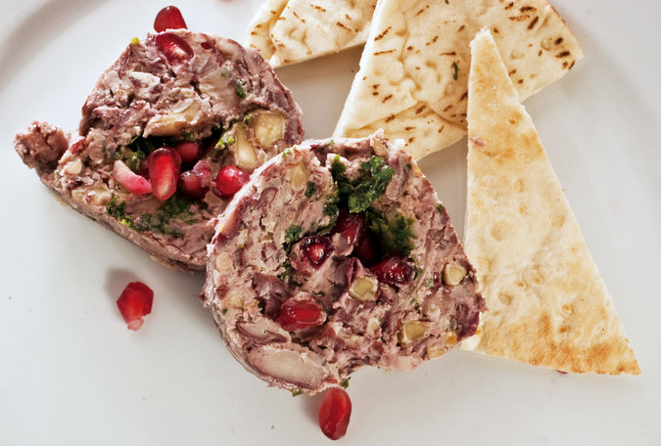
At her restaurant, Oleanna, in Cambridge, Mass., Chef Ana Sortun serves this popular dip with homemade string cheese and bread. To prepare it, Ms. Sortun spreads the dip out on plastic wrap, tops with herbs, pomegranate molasses and pomegranate seeds, and rolls the whole thing up. She then serves it in slices. Here we make the dip plain, spread it on Wasa Lite crackers, and use the herbs and pomegranate seeds on top.
Featured in: Well's Vegetarian Thanksgiving 2011.
LEARN: How to Cook Beans
Vegetarian, Vegan, Dairy Free, Kosher
Cooked

Rate this

INGREDIENTS
- 1 cup dark red kidney beans, soaked overnight and rinsed well
- 3 cups water
- ¼ white onion, minced
- 1 bay leaf
- ¾ cup walnuts
- 4 tablespoons (1/2 stick) butter
- Salt and pepper to taste
- 2 teaspoons chopped dill
- 2 teaspoons chopped mint or basil
- 2 teaspoons chopped flat-leaf parsley
- 2 teaspoons pomegranate molasses(you can find this at Whole Foods or similar markets)
- Bread, crackers and string cheese for serving

GARNISH
- Garnish for older children and adults: toasted walnuts
- pomegranate seeds

Nutritional Information

PREPARATION
- Combine beans, water, onion and bay leaf in a saucepan and bring to a boil. Turn heat down to low and simmer until tender, about an hour.
- Heat oven to 350 degrees. Spread the walnuts out on a baking tray and toast for about 8 to 10 minutes, stirring once, and checking frequently until toasted.
- Drain beans well and discard bay leaf. In a food processor fitted with a metal blade, puree the beans with walnuts, butter, chopped garlic, salt and pepper until smooth and creamy.
- Mix chopped herbs together and put aside a small amount for garnish. Blend the rest into the beans and add a splash of water if the mixture is too thick.
- Season with salt and pepper and serve on warmed bread slices or crackers. Drizzle with pomegranate molasses and sprinkle with herb mix.
- Serve next to some string cheese. For older children and adults, top with walnuts and pomegranate seeds.

