Quick-Pickled Vegetable Salad

ALEXA WEIBEL
- YIELD4 servings
- TIME20 minutes
Save to Recipe Box
EmailShare on PinterestShare on FacebookShare on Twitter
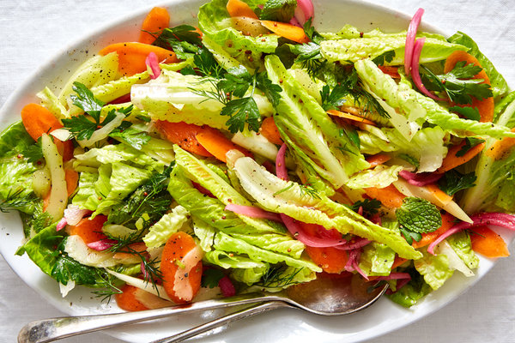
Yossy Arefi for The New York Times (photography and styling)

INGREDIENTS

FOR THE PICKLED RED ONIONS:
1 small red onion, very thinly sliced from tip to tip
½ cup apple cider vinegar, red wine vinegar or champagne vinegar
¼ cup granulated sugar
2 tablespoons coriander seeds (optional)
2 teaspoons kosher salt

FOR THE SALAD:
2 large celery stalks, trimmed and thinly sliced on a sharp angle
2 medium carrots, peeled and very thinly sliced lengthwise using a mandoline or thinly sliced diagonally
3 tablespoons extra-virgin olive oil
1 teaspoon fresh lemon zest and 2 tablespoons juice (from 1 lemon), or 2 tablespoons vinegar
8 cups torn butter lettuce or romaine hearts (6 to 8 ounces)
3 small radishes, very thinly sliced (optional)
⅔ cup torn or chopped mixed fresh herbs (any combination of parsley, dill, basil, mint or chives) (see Tip)
2 to 4 teaspoons coarse or Dijon mustard, to taste

PREPARATION
Prepare the pickled onions: Set the sliced onion in a small heatproof bowl. Combine the vinegar, sugar, coriander seeds (if using), salt and 1/2 cup water in a small saucepan. Bring to a boil over high, then pour over onions. Stir to combine, let cool, then transfer onions and brine to a lidded container. Refrigerate until chilled. (Makes about 2/3 cup drained onions. Onions will keep up to 3 weeks.)
Prepare the salad: In a medium bowl, combine the celery, carrots, olive oil, lemon zest and juice. Season generously with salt and pepper and toss to coat.
When ready to serve, add the lettuce, radishes (if using) and herbs to a large bowl, season lightly with salt and pepper and gently toss to coat. Using a slotted spoon or tongs, transfer the celery and carrots to the vegetables in the large bowl, leaving the vinaigrette behind in the medium bowl.
To the vinaigrette, add the mustard, 1/4 cup drained pickled red onions and 4 teaspoons of the pickled red onion brine and stir to combine; season to taste. Add vinaigrette to salad, toss to coat and season. Serve immediately.

