Provoleta (Grilled Provolone Cheese)

DAVID TANIS
- YIELD4 to 6 servings
- TIME30 minutes
Save To Recipe Box
Print this recipe
EmailShare on PinterestShare on FacebookShare on Twitter
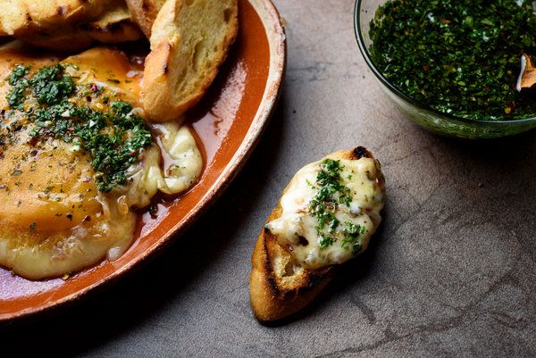
Karsten Moran for The New York Times
In Argentina, a thick slice of provoleta, a provolone-type cheese, is cooked over coals until browned and bubbling, then served as a mouthwatering appetizer with bread.

INGREDIENTS

FOR THE CHIMICHURRI:
- ½ cup finely chopped parsley
- 1 tablespoon finely chopped fresh oregano or 1 teaspoon dried
- 2 or 3 garlic cloves, minced
- ½ cup extra-virgin olive oil
- Salt and pepper, to taste
- Large pinch of crushed red pepper
- 1 tablespoon red wine vinegar
- 2 tablespoons cold water

FOR THE CHEESE:
- 8 ounces provolone cheese, sliced at least 1 inch thick
- 1 tablespoon roughly chopped fresh oregano or 1 teaspoon dried
- ½ teaspoon crushed red pepper
- 1 baguette, sliced in 1/2-inch rounds, toasted, if desired

PREPARATION
- Make the chimichurri: In a small bowl, stir together the parsley, oregano, garlic, olive oil, salt and pepper, crushed red pepper, vinegar and water. Thin with a little more water, if necessary, to make a pourable sauce. Set aside to let flavors meld. Sauce may be prepared up to 1 hour in advance.
- Set a small cast-iron pan over medium-high heat (or over hot coals). When pan is hot, put in the cheese. Sprinkle with half the oregano and crushed red pepper.
- Cook for about 2 minutes, until the bottom begins to brown. Carefully flip the cheese with a spatula and cook for 2 to 3 minutes more, until the second side is browned and the cheese is beginning to ooze. Transfer cheese to a plate and sprinkle with remaining oregano and crushed red pepper. Serve immediately, accompanied with bread and chimichurri. (Alternatively, finish the cheese by putting it under the broiler or in a hot oven.)

