Pickleback Slaw
YIELD6 to 8 servings,
Andrew Scrivani for The New York Times

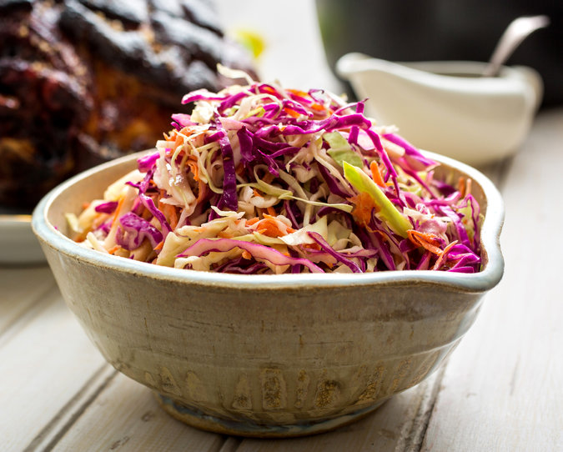

- 1 small head green cabbage
- 1 small head red cabbage
- 2 carrots, peeled and grated
- 2 tart apples, like Granny Smith, peeled and cut into matchsticks
- ½ cup mayonnaise, preferably homemade or Hellmann’s
- 3 tablespoons juice from a pickle jar, or of pickle relish
- 1 tablespoon Dijon mustard
- 1 tablespoon cider vinegar
- 2 teaspoons pepper sauce, like Frank’s, or to taste
- Kosher salt
- Ground black pepper

- Cut the cabbages in half and remove the core from each side. Cut each half in half and slice each resulting quarter into thin ribbons. Mix with carrots and apples in a large nonreactive bowl.
- In a separate bowl, whisk together the remaining ingredients.
- Pour the dressing over the cabbage and toss. Season to taste. The coleslaw may be covered with plastic wrap and refrigerated. Toss again before serving.

COOKING NOTES
Judith Bluysen a year ago
Replace the apple with diced red &/or green pepper, sprinkle in a tsp or 2 of caraway seeds, double the vinegar/pickle juice, bring it with the mustard, S&P to a boil, pour it over the veggies to slightly wilt them. Allow to marinate an hour or more in fridge, then add mayo and mix with hands. (Lick hands before serving.)

