Peppermint Bark Pavlova

William and Sonoma
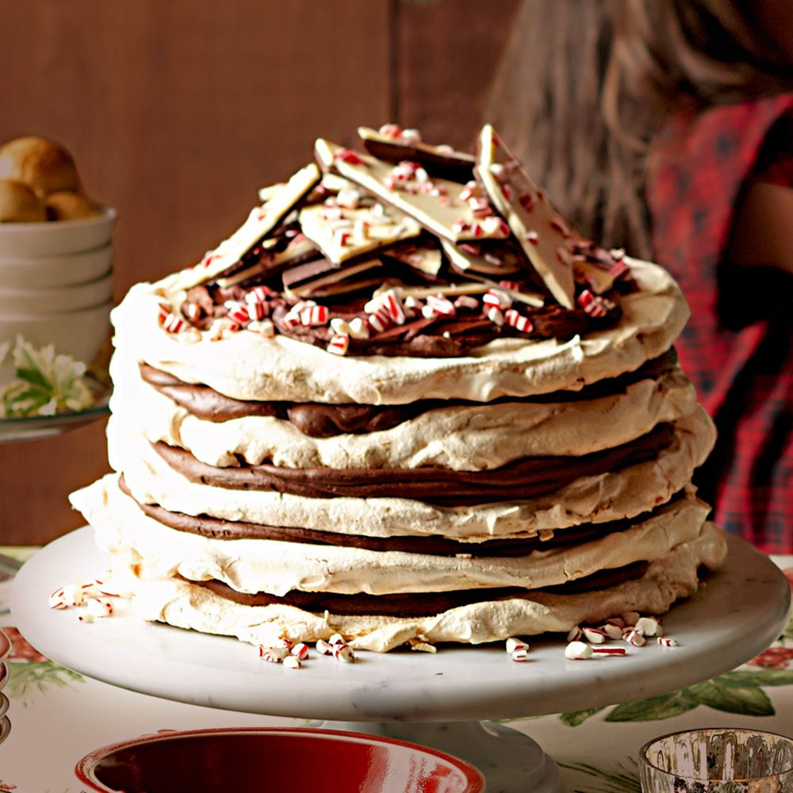
This layered dessert will make a stunning centerpiece for a holiday buffet. To make it easier to create even layers of meringue, draw a circle guideline on each sheet of parchment paper, then place the parchment on a baking sheet. If you don’t have a pastry bag, place large scoops of the meringue in the center of each circle guideline and use an offset spatula to carefully spread the meringue to the edges of the circle, forming an even layer. Whip the ganache just before assembling the pavlova; it can quickly become too firm to work with.

Ingredients:
- 2 1/2 cups (630 g) sugar
- 2 Tbs. cornstarch
- 12 egg whites
- 2 pinches of kosher salt
- 1 tsp. cream of tartar
- 1 tsp. vanilla extract
- 1 1/4 lb. (625 g) bittersweet chocolate, roughly chopped
- 2 1/2 cups (625 ml) heavy cream
- 1 tin (1 lb./500 g) peppermint bark, 1 sheet broken into small
pieces, 1 sheet broken into large shards
- Vanilla ice cream for serving (optional)

Directions:
Have all the ingredients at room temperature.
Position 1 rack in the upper third and 1 rack in the lower third of an oven. Preheat the oven to 250°F (120°C). Line 2 baking sheets with parchment paper.
In a small bowl, whisk together 1 1/4 cups (315 g) of the sugar and 1 Tbs. of the cornstarch until evenly distributed. Set aside.
In the bowl of an electric mixer fitted with the whisk attachment, beat together 6 of the egg whites, 1 pinch of salt and 1/2 tsp. of the cream of tartar on low speed until frothy, about 30 seconds. Increase the speed to medium and beat for 30 seconds more. Increase the speed to medium-high and slowly add the sugar mixture. Beat for 1 minute, then add 1/2 tsp. of the vanilla. Continue beating until the mixture is glossy and stiff peaks form, 1 to 2 minutes more. Transfer the meringue to a pastry bag fitted with a 3/4-inch (2-cm) round tip.
Starting in the center of each prepared baking sheet, pipe a 9-inch (23-cm) round of meringue, working outward in a spiral fashion. Using an offset spatula, gently spread the meringue so it is level and flat. Transfer the baking sheets to the oven and bake until the meringues are just slightly browned and dry to the touch, about 1 1/4 hours, switching the sheets between the racks and rotating them 180 degrees halfway through baking.
Transfer the parchment sheets with the meringues on them to wire racks. When the meringues are cool to the touch, gently remove them from the parchment and place directly on the racks.
Wash and dry the mixer bowl and whisk. Repeat the process with the remaining sugar, cornstarch, egg whites, salt, cream of tartar and vanilla, and bake and cool 2 more rounds of meringue.
Wash and dry the mixer bowl and whisk. Place the chocolate in the mixer bowl.
In a small saucepan over medium-high heat, bring the cream to a simmer. Pour over the chocolate and let stand for 2 minutes, then stir until the chocolate is completely melted and the mixture is smooth. Let cool to room temperature, about 2 hours.
Set the bowl on the mixer fitted with the whisk attachment. Beat on medium-high speed until the ganache is light and fluffy, 2 to 3 minutes. Transfer the ganache to a clean pastry bag fitted with a 3/4-inch (2-cm) round tip.
To assemble the pavlova, pipe a small dollop of the ganache on a cake stand or platter. Place 1 meringue round on top, pipe a layer of the ganache on the meringue and sprinkle with one-third of the small peppermint bark pieces. Repeat the layers, ending with a layer of ganache on top of the fourth meringue round. Top with the large peppermint bark shards. Serve the pavola with vanilla ice cream. Serves 12.

