Peking duck pancakes
Roll up, roll up, for this traditional Peking duck pancake dinner.
To my cookbook
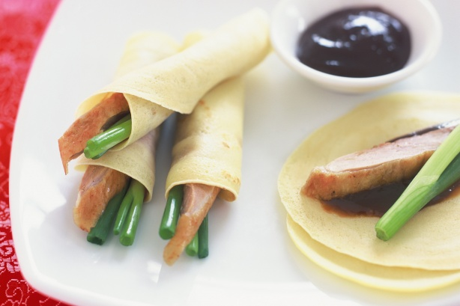
1/2 cup plain flour
2 tablespoons corn flour
1/4 cup water
1/4 cup milk
2 eggs
2 tablespoons butter, melted
1 Peking duck
6 green onions, washed
1/2 cup hoisin sauce
Select all ingredients

- Step 1
Combine flour, corn flour, water, milk, eggs and half the butter in a food processor. Process until batter is smooth. Pour into a jug. Cover and stand for 15 minutes.
- Step 2
Heat a non-stick frying pan over medium heat. Brush with remaining butter. Pour a tablespoonful of batter into frying pan. Spread to form a thin pancake, about 16cm in diameter. Cook for 2 minutes. Turn and cook for a further 1 minute. Transfer to a plate. Repeat with remaining batter.
- Step 3
Remove skin and meat from duck. Thinly slice both skin and meat. Cut onions into 10cm lengths.
- Step 4
Place some duck skin and meat, 2 pieces of onion and 1 teaspoon of hoisin sauce onto each pancake. Roll up. Serve.

