Pecan Pie Truffles

TARA PARKER-POPE

- YIELD24 truffles
Save To Recipe Box
Print this recipe
Share on FacebookShare on PinterestShare on TwitterEmail
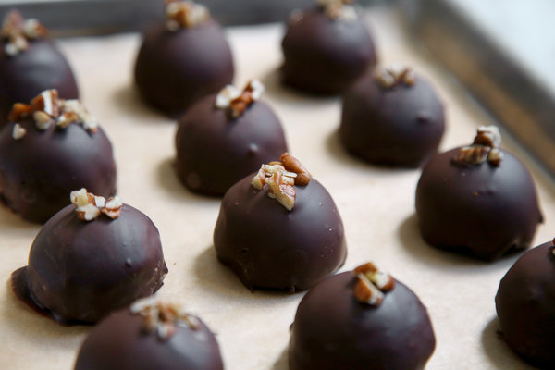
Jim Wilson/The New York Times
These festive truffles from Hannah Kaminsky, a columnist at VegNews Magazine, combine the rich flavors of pecan pie under a thin layer of smooth chocolate. Like traditional rum balls, these offer a slightly alcoholic kick, so be sure to monitor any underage guests.
Featured in: Well's Vegetarian Thanksgiving 2010.
Vegetarian, Vegan, Dairy Free, Kosher, Dark Chocolate, Pecan

Mark as Cooked

293 ratings

INGREDIENTS
- 2 ½ cups pecans, toasted and finely chopped
- 1 cup graham cracker crumbs (from about 8 whole graham crackers)
- 1 cup dark brown sugar, packed
- ½ teaspoon salt
- 2 tablespoons maple syrup
- ¼ cup bourbon
- 1 teaspoon vanilla
- 7 ounces dark chocolate

Nutritional Information

PREPARATION
- In a medium bowl, stir together pecans, graham cracker crumbs, brown sugar and salt until well combined. Add maple syrup, bourbon and vanilla, stirring thoroughly. Use your hands to make sure the mixture becomes fully incorporated.
- Form mixture into walnut-sized balls, then place on a cookie sheet and freeze for 2 hours.
- In the top of a double boiler or in a medium stainless steel bowl set over a pot of gently simmering water, melt chocolate (we recommend tempering the chocolate, but if you don't, they'll still be delicious, just a bit messy). Line a baking sheet with parchment paper. Dip the frozen balls into the melted chocolate, then place onto prepared baking sheet. Let sit for 15 minutes or until firm.

