Pea, Butter Lettuce & Herb Salad
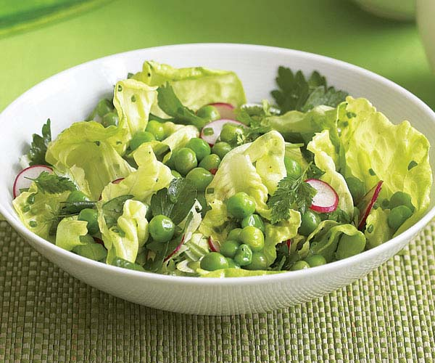
Serves four.

- 1 cup fresh shelled peas (about 1 lb. unshelled) or frozen peas
- Kosher salt
- 3 Tbs. extra-virgin olive oil
- 1 Tbs. fresh lemon juice
- 1 tsp. finely grated lemon zest
- Freshly ground black pepper
- 1 small head butter lettuce, washed and dried, leaves torn into bite-size pieces
- 6 medium strawberries, thinly sliced
- 4 scallions (white and light-green parts), thinly sliced on the diagonal
- 1/4 cup loosely packed fresh oregano leaves
- 3 oz. crumbled feta (optional)
If using fresh peas, sample them. If they are young, sweet, and tender, keep them raw. If they are older and a bit tough, blanch them in a small pot of boiling salted water until just tender, 2 to 4 minutes. Drain and spread them on a baking sheet in a single layer to cool. If using frozen peas, thaw them by leaving them at room temperature or by running them under warm water.
In a small bowl, whisk the oil with the lemon juice, lemon zest, and salt and pepper to taste.
Just before serving, toss the peas in a small bowl with 1 Tbs. of the dressing. Toss the butter lettuce, radishes, scallions, and herbs in a large bowl with just enough of the remaining dressing to lightly coat. Season to taste with salt and pepper.
Arrange the salad on individual serving plates and top with the peas and the ricotta salata (if using).

