Pasta With Fresh Herbs, Lemon and Peas

- YIELDServes four

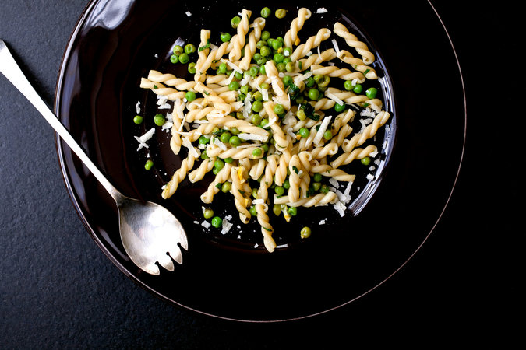
Andrew Scrivani for The New York Times

- ½ cup finely chopped fresh herbs, such as parsley, basil, tarragon, mint and chives
- Zest of 1 organic lemon, finely chopped
- 1 garlic clove, finely minced
- 2 tablespoons fresh lemon juice
- 3 tablespoons extra virgin olive oil
- Salt to taste
- ¾ pound pasta, any type
- 1 cup frozen peas, thawed
- ¼ cup freshly grated Parmesan or pecorino

PREPARATION
- Bring a large pot of water to a boil. Meanwhile, in a large bowl or pasta bowl, combine the herbs, lemon zest, garlic, lemon juice and olive oil.
- When the water comes to a boil, salt generously and add the pasta. Follow the cooking instructions on the package, but check the pasta a minute before the indicated time. A few minutes before the pasta is done, add the peas to the water. When the pasta is just about al dente, remove a half cup of the cooking water and add to the bowl with the herbs. Drain the pasta and peas, toss with the herb mixture and the cheese, and serve.

Tip
- Advance preparation: The herbs can be chopped several hours ahead, but don’t combine the ingredients until you’ve put the water on for the pasta.

