Everything Parker House Rolls

ERIN JEANNE MCDOWELL
- YIELD12 rolls
- TIME40 minutes, plus 2 1/2 hours’ rising
Save To Recipe Box
Print this recipe
EmailShare on PinterestShare on FacebookShare on Twitter
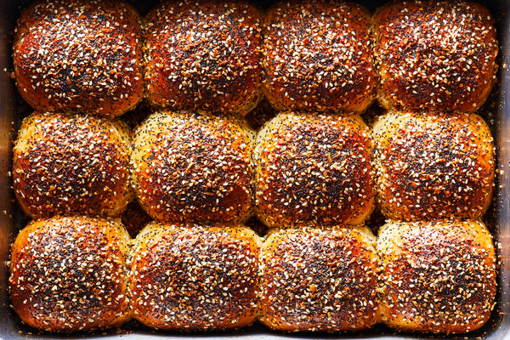
Julia Gartland for The New York Times. Food Stylist: Ali Slagle.
There’s nothing better than a warm Parker House roll, except maybe one with a salty, seedy everything-bagel topping. While there are a million subtle variations of the classic roll, this recipe keeps the shape simple (just basic rounds) for the most buttery, fluffiest results. You can purchase everything-bagel seasoning in the spice section of some supermarkets, but it’s also easy to make your own.
Dry Milk Powder, Instant Yeast, Poppy Seed

Mark as Cooked

155 ratings

INGREDIENTS

FOR THE ROLLS:
- 1 cup/237 milliliters whole milk
- 4 tablespoons/57 grams (1/2 stick) unsalted butter, plus more for greasing
- 3 ½ cups/448 grams all-purpose flour
- ⅓ cup/32 grams dry milk powder
- ¼ cup/50 grams granulated sugar
- 2 ¼ teaspoons instant yeast powder
- 1 teaspoon kosher salt
- 2 large eggs

FOR THE TOPPINGS:
- 2 tablespoons sesame seeds
- 2 tablespoons poppy seeds
- 1 ½ tablespoons dried garlic flakes
- 1 ½ tablespoons dried minced onion
- 2 teaspoons kosher salt
- 6 tablespoons/85 grams (3/4 stick) melted unsalted butter, for brushing

Nutritional Information

Email Grocery List

PREPARATION
- Prepare the rolls: In a medium pot, heat the milk and 4 tablespoons butter over medium until the mixture is just warm to the touch (about 95 degrees) and the butter is melted, 1 to 2 minutes.
- In the bowl of an electric mixer fitted with a dough hook attachment, combine the flour, milk powder, sugar, yeast and salt with 1 egg and the warmed milk mixture. Mix on low for 3 minutes, then increase the speed to medium and mix until the dough is smooth, about 3 minutes.
- Transfer the dough to a lightly greased bowl, cover with plastic wrap, and let rise in a warm place for 1 1/2 hours. The dough may not double in size, but it should be noticeably puffy.
- Divide the dough into 12 even pieces (about 71 grams each). Gently round into balls: Cup your hand and fingers around a piece of dough then roll it on your work surface until it forms a tight ball. Repeat with the remaining pieces.
- In a lightly greased 9-by-13-inch pan, arrange the balls in three rows of four. Cover the rolls with plastic wrap and let rise in a warm place until noticeably puffy, 45 minutes to 1 hour.
- Heat the oven to 350 degrees. Prepare the everything-bagel seasoning: Toss together the sesame seeds, poppy seeds, dried garlic, dried onion and kosher salt.
- In a small bowl, beat the remaining egg. Brush the surface of each roll with the beaten egg and sprinkle each generously with everything-bagel seasoning (about 2 teaspoons per roll).
- Bake the rolls for 10 minutes, then brush the surface of the rolls generously with the melted butter. Bake until the rolls are evenly golden-brown, 15 to 20 minutes. Brush the baked rolls generously with the remaining melted butter. Let cool 10 to 15 minutes before serving. Store leftover rolls at room temperature in a resealable plastic bag. (See tip for reheating instructions).

Tips
- To reheat, wrap each roll in a lightly damp paper towel, and microwave for 20 to 25 seconds. Unwrap the rolls and serve immediately.

