Pad Kee Mao

MARK BITTMAN
- YIELD4 servings
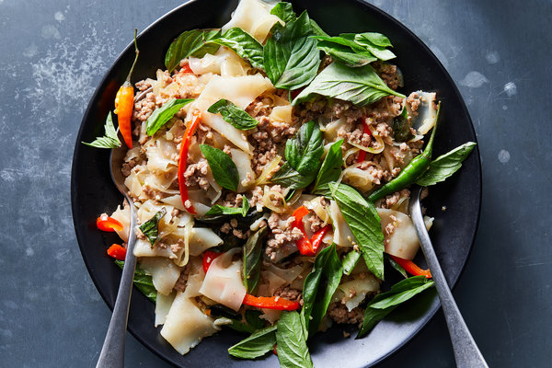
Julia Gartland for The New York Times. Food Stylist: Liza Jernow.
This stir-fry of rice noodles and ground pork gives Pad Thai a serious run for its money. Pad kee mao translates loosely to “drunken noodles,” though there’s no alcohol here — just an easy-to-assemble dish that skews salty, sour and spicy from a glaze of fish sauce, soy sauce, rice vinegar and fresh chiles. Fatty ground pork imparts a lot of flavor, though you could swap in ground chicken or even firm tofu. If you’re sensitive to heat, leave out the smashed chiles, to finish — and add a pinch of sugar to offset the salty punch of the dish.

- 4 tablespoons fish sauce
- 2 tablespoons dark sweet soy sauce(kecap manis) Regular soy sauce mixed with brown sugar, added with a trace of molasses, can serve as a substitute for sweet soy sauce.
- 1 teaspoon rice vinegar
- 6 garlic cloves
- 5 bird’s eye chiles, dried, hot red chilies
- 3 tablespoons vegetable oil
- ½ cup sliced onion
- 1 pound ground pork
- ½ cup sliced bell peppers
- 12 ounces fresh rice noodles
- 2 handfuls holy basil leaves (or Thai basil, in a pinch)

- Whisk together the fish sauce, soy sauce and vinegar, and set aside. Roughly chop the garlic and three chiles together. Smash the remaining two chiles using the flat of a knife, and set aside.
- Heat a wok (or a large frying pan over medium-high. When it’s hot, add the oil, the chopped garlic and chiles, and the onion. Cook, stirring constantly, until the garlic is fragrant, about 30 seconds. Add the pork and a splash of the fish sauce mixture. Cook, stirring to break up the meat, until the pork is cooked through, about 5 minutes.
- Add the bell peppers and noodles, turn the heat to high and add almost all of the sauce (save a spoonful or two to add later, if needed). Cook, tossing everything together and separating the noodles if necessary, until the noodles are coated in sauce and take on a slightly charred flavor from the wok. Taste, and add more sauce if needed. Toss in the basil and the smashed chiles, and serve immediately.

