No-Bake Chocolate Mousse Bars

By Samantha Seneviratne
- YIELD24 servings

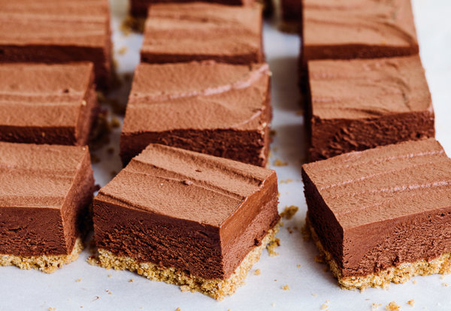
Todd Wagner for The New York Times

INGREDIENTS

FOR THE CRUST:
- 18 whole graham crackers (about 9 1/2 ounces/269 grams)
- 8 tablespoons/113 grams unsalted butter (1 stick), melted
- 2 tablespoons granulated sugar
- ¼ teaspoon kosher salt

FOR THE FILLING:
- 1 pound/454 grams semisweet chocolate, finely chopped
- 3 cups cold heavy cream, plus more for serving
- 2 teaspoons instant espresso powder
- ½ teaspoon kosher salt
- 1 tablespoon pure vanilla extract
- Whipped cream (optional)
Add to Your Grocery List
Ingredient Substitution Guide

Nutritional Information

PREPARATION
- Make the crust: Line a 9-inch-by-13-inch baking pan with parchment paper, leaving a 2-inch overhang on 2 sides. In a food processor, or in a resealable plastic bag, crush the graham crackers until you have fine crumbs (but stop before you have dust). You should have about 2 1/4 cups. Transfer the crumbs to a medium bowl. Add the butter, sugar and salt and stir until evenly moistened. Tip the crumbs into the prepared pan and press them down into an even layer on the bottom. Transfer to the freezer while you prepare the filling.
- Make the filling: Set the chocolate in a medium bowl. In a small saucepan, heat 1 cup cream, espresso powder and salt until hot but not boiling. Pour the hot cream mixture over the chocolate and let it stand for 2 minutes. Add the vanilla and whisk until smooth. Set aside to cool completely.
In a large bowl or in the bowl of a stand mixer fitted with the whisk attachment, whip the remaining 2 cups heavy cream until you have stiff peaks. Add the chocolate mixture and gently fold to combine. Pour the mixture over the prepared crust, and spread it out into an even layer. Cover with plastic wrap and chill until firm, at least 2 hours. To serve, cut the two edges without parchment free with a sharp knife then use the parchment overhang to transfer the bar to a cutting board. Cut into squares (To cut beautiful, neat slices, use a long sharp knife warmed in hot water and wiped clean before each cut). Serve with a dollop of whipped cream, if desired.

