Mushrooms and Dumplings

By Kay Chun
- YIELD4 Servings
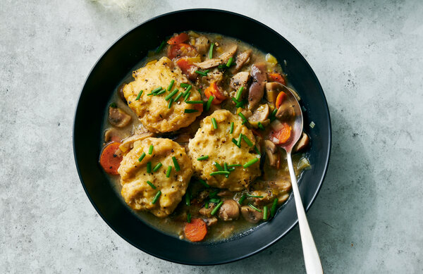

FOR THE MUSHROOMS:
- 3 tablespoons unsalted butter
- 2 tablespoons extra-virgin olive oil
- 2 medium leeks (1 pound), white and light green parts only, thinly sliced (2 cups)
- Kosher salt and black pepper
- 3 garlic cloves, minced
- 1 pound small white button or cremini mushrooms, quartered (5 1/2 cups)
- 8 ounces shiitake mushrooms, thinly sliced (about 3 cups)
- 2 carrots, thinly sliced (1 cup)
- 3 dried shiitake mushrooms, grated on a Microplane and stems discarded (1/3 cup)
- 1 tablespoon all-purpose flour
- 4 cups mushroom broth
- 3 thyme sprigs
- 2 tablespoons heavy cream or whole milk
- Chopped chives, for garnish

FOR THE DUMPLINGS:
- 1 ½ cups/205 grams all-purpose flour
- 1 ½ teaspoons kosher salt (Diamond Crystal)
- ½ teaspoon baking powder
- ¼ teaspoon black pepper
- ¼ teaspoon baking soda
- 1 large egg
- ½ cup/120 grams whole milk
- 3 tablespoons/45 grams butter, melted

PREPARATION
- Prepare the mushrooms: In a large Dutch oven, melt 1 tablespoon of the butter in 1 tablespoon of the oil over medium-high. Add leeks, season with salt and pepper, and cook, stirring occasionally, until softened, 3 minutes. Stir in garlic until fragrant, 1 minute. Add fresh mushrooms, carrots, the remaining 2 tablespoons butter and 1 tablespoon oil, and season with salt and pepper. Reduce heat to medium and cook, stirring occasionally, until mushrooms are softened and lightly golden, about 5 minutes.
- Stir in grated shiitake powder and flour until mushrooms are evenly coated, about 1 minute. Add broth, 2 cups of water and thyme, and bring to a boil over high. Reduce heat to medium and simmer, partially covered, for 10 minutes. Uncover and simmer until reduced and slightly thickened, about 5 to 10 minutes longer. Discard thyme sprigs, and stir in cream.
- As the mushrooms simmer, make the dumplings: In a medium bowl, whisk flour, salt, baking powder, black pepper and baking soda until well combined. In a small bowl, whisk egg, milk and butter until well blended, then add to dry mixture and fold just until a dough forms. Refrigerate until ready to use.
- Drop 12 equal spoonfuls of the dough into the pot, leaving some space in between. Cover and simmer gently over low heat until dumplings are puffed and cooked through, about 15 minutes. Divide among 4 bowls and garnish with chives.

