Melted-Pepper-Ricotta Toast

FRANCIS LAM
- YIELD1 toast
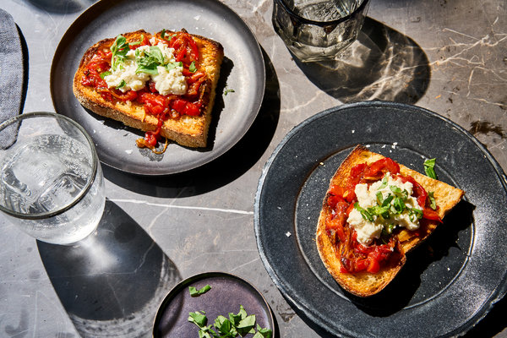
Gentl and Hyers for The New York Times. Food stylist: Maggie Ruggiero. Prop stylist: Pamela Duncan Silver.

INGREDIENTS
- 1 1/2-inch slice of country bread
- 3 to 4 tablespoons melted-pepper spread, or to taste
- 2 to 3 tablespoons ricotta cheese, to taste
- Flaky salt
- Mint or basil leaves, roughly torn, for garnish
Add to Your Grocery List
Ingredient Substitution Guide

Nutritional Information

PREPARATION
- Toast the bread well, and spread it with the peppers. Drop on the ricotta in dollops, and season them with flaky salt. Scatter on a few torn mint or basil leaves, and serve immediately.

Pepper Ricotta Toast Spread Francis Lam, NY Times Cooking
4 Servings

Pepper Spread
12 ounces onion (about 2 medium)
¼ cup extra-virgin olive oil
kosher salt
1 ½ pounds red bell peppers (about 3 medium)
4 cloves garlic, thinly sliced
1 teaspoon fresh thyme leaves (about 6 sprigs)
1 ½ teaspoons red-wine vinegar, or to taste
pinch of sugar

Assembly
6 large slices sourdough bread
whole milk ricotta cheese
kosher salt
Pepper Spread (see above)
basil leaves, roughly torn, for garnish

Pepper Spread: Slice the onions thinly, into 1/8-inch half-moons. Stem, seed and slice the peppers into 1/8-inch strips.
Heat the oil in a large, tall-sided skillet over medium heat. Stir in onions, peppers, garlic and 2 big pinches of salt. Stir every couple of minutes so they become soft without getting too much color. Keep a close eye on the pan, and stir more frequently and add a little water so it doesn’t burn.
When the peppers are very soft and spreadable add the thyme and vinegar and cook, stirring, for 1 more minute. Taste, and add more salt or vinegar if desired. Remove the peppers from the heat, and let cool. Store, refrigerated, for up to 2 weeks. It tastes best at room temperature or warm.
Assembly: Toast the bread well; spread with ricotta and season with salt. Spread the peppers over the ricotta and garnish with basil leaves. Serve immediately.

