Meatball Toad-in-the-Hole

YOTAM OTTOLENGHI
- YIELD6 servings
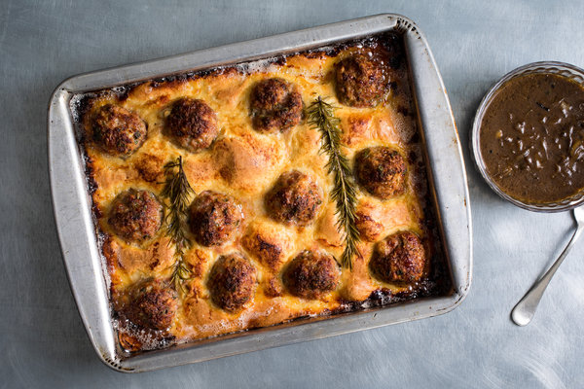
Andrew Scrivani for The New York Times
This version of the British classic has meatballs instead of the traditional sausages, but feel free to revert to the original if you like. It is served with a rich onion gravy that is made in the oven, just like the main dish. The secret to a perfect toad-in-the-hole, in which the batter gets airy and crisp on the surface but remains soft and bready on the bottom, is making sure your oil is smoking hot when you pour in the batter, so be sure to heat up the oil well and then work quickly when adding the batter. This is best eaten immediately out of the oven, as it starts to deflate as it sits.

FOR THE BATTER:
- 4 large eggs
- 1 cup/240 milliliters whole milk
- ⅔ cup/160 milliliters India pale ale or another pale ale
- 2 tablespoons Dijon mustard
- 1 ¾ cups/225 grams all-purpose flour(plain flour), sifted
- 1 teaspoon kosher salt

FOR THE GRAVY:
- 2 tablespoons sunflower oil
- 1 tablespoon/15 grams unsalted butter
- 2 small onions (about 12 ounces/350 grams total), halved and thinly sliced
- 2 rosemary sprigs
- 3 tablespoons balsamic vinegar
- 1 ½ tablespoons all-purpose flour (plain flour)
- 2 cups/480 milliliters chicken stock
- ⅓ cup plus 1 tablespoon/100 milliliters India pale ale
- Kosher salt and black pepper

FOR THE MEATBALLS:
- 7 ounces/200 grams sourdough bread, crusts discarded and bread cut into 1/4-inch (1/2-centimeter) cubes
- ¾ cup/180 milliliters whole milk
- 1 ½ pounds/700 grams ground pork(pork mince)
- 4 ounces/115 grams pancetta, very finely chopped
- 1 very small onion (about 3 ounces/80 grams), grated
- ⅓ packed cup/20 grams roughly chopped parsley
- 4 garlic cloves, crushed
- 1 ½ teaspoons lemon zest
- Kosher salt and black pepper
- 6 tablespoons/90 milliliters sunflower oil
- 2 rosemary sprigs

PREPARATION
- Heat the oven to 475 degrees Fahrenheit/240 degrees Celsius.
- Prepare the batter: Add the eggs, milk, beer and mustard to a large bowl, and whisk vigorously until foamy, about 1 minute. Add the flour and salt to a separate large bowl, making a well in the center, and pour the egg mixture into the well, in about four increments, whisking lightly each time until the flour is just incorporated. Whisk until there are no lumps and the ingredients are just combined, taking care not to overwork the batter. Set aside for at least 30 minutes, or while you continue with the next step.
- Prepare the gravy: Add the oil, butter, onions, rosemary and vinegar to a 9-by-13-inch (23-by-33-centimeter) baking dish (tin). Bake, stirring a couple of times during cooking, until the onions are thoroughly collapsed and browned, about 20 minutes. Whisk together the flour, stock and beer in a bowl until smooth. Add 1/2 teaspoon salt and a good grind of pepper, then pour flour mixture into the baking dish. Return to the oven and bake, stirring twice throughout, until the gravy is thick and rich, 20 to 25 minutes. Discard the rosemary sprigs and keep warm.
- While the gravy is cooking, prepare the meatballs: Soak the bread in the milk in a small bowl and set aside until the liquid is absorbed, 10 minutes. Use your hands or a fork to break apart the bread into a lumpy mash. In a large bowl, mix together the ground pork (pork mince), pancetta, onion, parsley, garlic and lemon zest with 1 teaspoon salt and a generous amount of pepper. Add the bread and use your hands to knead the mixture until it is very well mixed. Shape into 12 large meatballs.
- Spread 2 tablespoons sunflower oil across the bottom of a large roasting pan (tin), about 9-by-13-inches (23-by-33-centimeters) in size. Add the meatballs and bake for 10 minutes, or until some of their liquid has been released. Transfer the meatballs to a baking sheet (tray) lined with paper towels to absorb any excess moisture. Pour the liquid released from the meatballs in the roasting pan directly into the gravy, and then wipe the roasting pan dry.
- Add the remaining 4 tablespoons sunflower oil to the meatball roasting pan and return to the oven until very hot and beginning to smoke, about 10 minutes. Working as quickly as possible, pour the batter into the pan (it should bubble around the edges) and then add the meatballs and 2 rosemary sprigs. Return to the oven immediately and bake for 15 minutes. Reduce the temperature to 400 degrees Fahrenheit/210 degrees Celsius (don’t open the oven!) and bake for 30 minutes more, or until golden and well risen. (If you want, you can sneak the gravy into the oven to rewarm during the last 5 minutes of baking.) Serve immediately, with the gravy alongside.

