Mario Batali’s Spicy Shrimp Sauté

THE NEW YORK TIMES

- TimeAbout 15 minutes

- Yield4 servings
Save
Add to a collection
Share on FacebookShare on PinterestPrint this recipe
More
EASY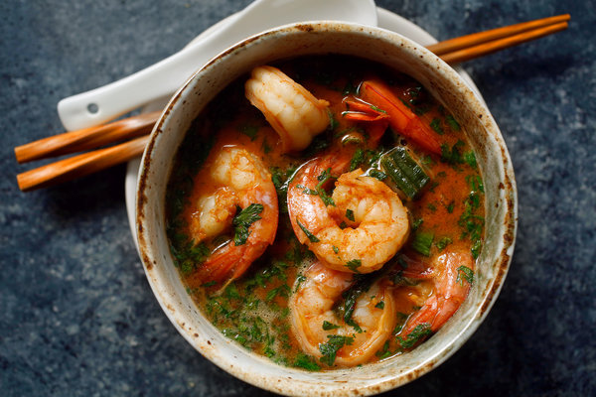
Craig Lee for The New York Times
After up to 10 hours of standing with virtually no breaks and no real nourishment, a famished team of chefs, cooks, waiters, bussers, porters and everyone else it takes to run a restaurant needs sustenance. The first order of business is the crucial component of, shall we say, rehydration. Thirst after a hot and sweaty shift is well earned and often slaked quickly and continuously till closing time with cold beer, sake or good-value wine. Keep in mind that often this rehydration is really the only thing on the chefs’ minds, depending on where the evening falls in the pay cycle. Sometimes the evening starts out as just drinking and continues that way into the early morning, when we end up at someone’s apartment and start preparing spicy dishes. Here is one of the best of those.
Featured in: The Predawn Chowdown.
Cooked

125 ratings

INGREDIENTS
- 2 tablespoons red curry paste
- ¼ cup fish sauce
- ¼ cup sambal
- ¼ cup sweet chili sauce
- 2 pounds medium shrimp, peeled and deveined
- 3 tablespoons light sesame oil
- 1 cup sliced scallions
- 2 tablespoons sweet soy sauce
- 1(14-ounce) can light coconut milk
- 1 bunch cilantro, chopped.

Nutritional Information

PREPARATION
- Combine curry paste, fish sauce, sambal and chili sauce in a medium bowl; add shrimp, tossing to coat. Place a large nonstick skillet over medium-high heat until hot. Add oil, and heat till smoking then add the shrimp mixture, and sauté for 2 minutes. Add scallions; cover, and cook for 3 minutes. Stir in sweet soy sauce and coconut milk. Cook for 3 minutes or until thoroughly heated and the shrimp is cooked through. Add cilantro and serve.
NOTES

Add photo

500
Leave a note for yourself or others.

