Mac and Queso Fundido

MARGAUX LASKEY
- YIELD4 servings

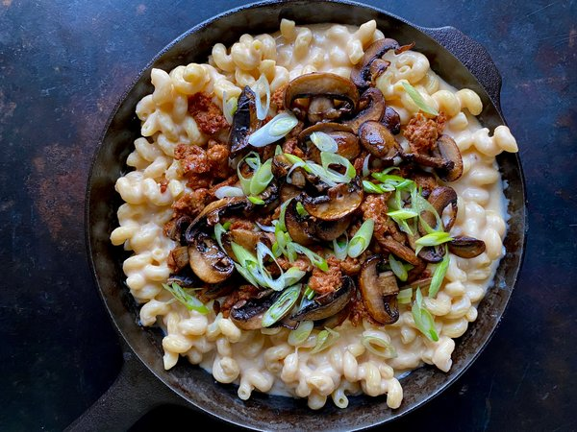
Susan Spungen for The New York Times (Photography and Styling)

INGREDIENTS
- Kosher salt and freshly ground black pepper
- 1 tablespoon vegetable or canola oil
- 5 ounces mushrooms, preferably cremini, sliced (about 2 cups)
- ¼ pound fresh chorizo or hot Italian sausage, casing removed (optional)
- 8 ounces cavatappi (corkscrew) or other small pasta
- 2 tablespoons unsalted butter
- 4 garlic cloves, minced
- 3 tablespoons all-purpose flour
- 1 cup chicken stock, vegetable stock or water
- ¾ cup milk
- ¼ cup heavy cream
- 1 teaspoon onion powder
- ½ teaspoon smoked paprika
- 1 ½ cups shredded mozzarella
- 1 cup shredded Mexican cheese blend
- ½ cup shredded Parmesan
- Sliced scallions, for serving

PREPARATION
- Bring a large pot of well-salted water to a boil over high heat for the pasta.
- As the water comes to a boil, heat the vegetable oil in a large skillet over medium. Add the mushrooms and cook until crispy and golden brown all over, about 5 minutes on each side. Season with a pinch of salt and pepper, and transfer to a plate. Wipe out the skillet.
- Line another plate with paper towels. Add the chorizo to the skillet and cook, crumbling the meat with a spatula, until the fat has rendered and the chorizo is crispy, 10 to 12 minutes. Remove and set aside on the paper towels to drain.
- Drop the pasta into the boiling water and cook according to the package directions. Drain and return the pasta back to the pot.
- Meanwhile, in the skillet, melt the butter over medium heat. Stir in the garlic and cook for 2 minutes. Whisk in the flour, then slowly whisk in the stock. Once the stock is incorporated, whisk in the milk and cream until smooth. Whisk in onion powder and smoked paprika, then cook until the mixture begins to thicken, about 3 minutes. Remove from the heat and stir in the mozzarella, Mexican cheese blend and Parmesan until completely melted. Adjust the salt to taste.
- Add the cheese sauce to the pasta and stir to evenly coat the pasta in the sauce. Leave in the pot or transfer to a serving dish and top with the mushrooms and chorizo, if using. Garnish with scallions and serve immediately.

