Jingalov Hats

TEJAL RAO
- YIELD4 (8-inch) hats
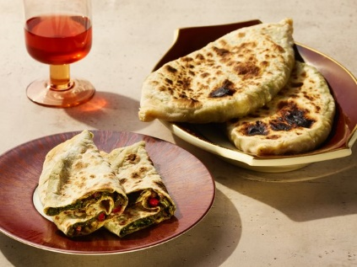

INGREDIENTS

FOR THE DOUGH:
- 1 ½ cups all-purpose flour, plus more for dusting
- 1 teaspoon kosher salt
- ⅔ cup lukewarm water
- Sunflower oil or other neutral oil, for greasing

FOR THE FILLING:
- 2 pounds chard, tough stems discarded
- 4 packed cups fresh cilantro, chervil and dill leaves and tender stems
- 4 packed cups radish greens and sorrel
- 6 spring onions (or 10 scallions), thinly sliced
- 3 tablespoons sunflower oil or other neutral oil
- 2 tablespoons fresh lemon juice
- 2 teaspoons sweet paprika
- 2 teaspoons kosher salt
- 2 handfuls pomegranate seeds (optional)
Add to Your Grocery List

PREPARATION
- Prepare the dough: In a medium bowl, combine 1 1/2 cups flour and the salt. Pour the lukewarm water into a large bowl, then gradually add the flour mixture, using your hands to incorporate. The dough will be sticky.
- Dust the counter with flour, turn dough onto it and knead gently until the surface becomes smooth and the dough stops sticking to your hands and counter, about 5 minutes. Roll the dough into a ball, place it in a lightly oiled bowl, turn it to coat, then cover it with a kitchen towel. Let it rest at room temperature for 20 minutes to 1 hour.
- Prepare the filling: Wash the greens, and use a salad spinner to dry them well. Chop the greens finely. Mix with spring onions, oil, lemon juice, paprika, salt and pomegranate seeds (if using), and set aside. Divide the rested dough into 4 portions, about 3 ounces each, and form each into a ball.
- On a lightly floured work surface, roll a ball into a very thin circle, about 8 inches wide, adding more flour as needed to prevent the dough from sticking. Place about 2 cups of filling in the center, then use your hands to pat it down into a round, leaving about a 1-inch border of dough. Pick up two opposite sides of the dough, and pinch them together over the center of the filling, from top to bottom, so the middle is wide and the ends form points.
- Firmly pinch the seam to make sure it’s sealed, then turn the dough over, and gently flatten it out with the palm of your hand so it resembles a deflated football, sealing any holes in the dough. It should be about 1/4- to-1/2-inch thick. If it’s thicker, use a rolling pin to smooth it out a little. Pinch shut any holes in the dough, then place on parchment or a lightly floured surface. Repeat with the remaining balls of dough.
- Heat a large cast-iron pan over medium-high. Working with one dough portion at a time, place the dough seam-side down in the center of the pan. Lower the heat to medium, and cook for about 3 minutes, until cooked and lightly browned in places. Flip, and cook the other side for 2 minutes. If the dough seems raw in places, flip and cook evenly. Repeat for the rest of the jingalov hats, and serve warm or at room temperature.

