How to Make One-Pot Pasta With Practically Any Pasta

One-pot pasta with broccoli and anchovies.Credit...Ali Slagle
By Ali Slagle

  - 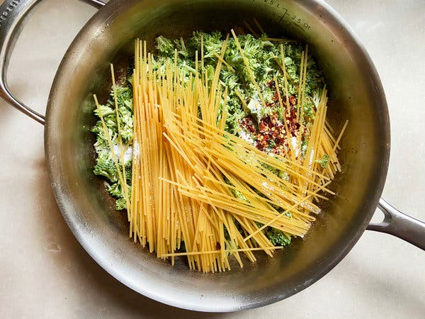

There’s one thing you can do to make any pasta dish easier, and arguably more satisfying: Cook the pasta and the sauce together in a single pot.
The technique hinges on the magic of the starchy cooking water, which is often added to pasta dishes to help the sauce come together. But here, the very water the pasta is cooked in seasons the noodles and becomes the velvety sauce. Practically any pasta that cooks in 10 minutes or less works, but make sure to use the correct ratio of pasta to water. That’s the key to the dish’s success.

The Method
1. In a 12-inch skillet with high sides (you could use a pan of a different size, but cook times and water amounts will vary), melt 4 tablespoons butter or heat 2 tablespoons extra-virgin olive oil over medium. Add any ingredients that need to be cooked through, like garlic, hearty vegetables, sausage or bacon. (See the Flavors section below for some ideas.)

2. Once they’ve softened, add 12 ounces of pasta (make sure it will cook in 10 minutes or less — anything with a longer cook time will be unevenly cooked), along with 5 cups water and 2 teaspoons salt. If the noodles don’t lie flat in the skillet, break them in half.

3. Turn the heat to high and cook, stirring and tossing the pasta constantly, until it is al dente, about 8 to 10 minutes. If it looks dry, add water. Season to taste with kosher salt and black pepper. Remove from heat and serve.

The Variations
With this formula, just about everything is adaptable: You can swap in all kinds of ingredients, change the cooking liquid and experiment with your noodles.
- This recipe is an especially great way to stretch vegetables and meat, or to employ ingredients that need to be used up. Add hearty vegetables and raw meats in Step 1, and add quick-cooking ingredients, like shrimp or peas, in Step 3 toward the end of cooking time.
- Swap out some or all of the water for broth, coconut milk or dashi.
- If you want a creamier pasta, add another 1/2 to 3/4 cup heavy cream or whole milk toward the end.
- You could also use udon, soba or ramen, but adjust the water and cook time. (It’s better to start with less liquid and add more if the pan looks dry.) Use rice or another grain and you’ve got faux risotto.

Hearty greens and chives: Cook the stems of chard, kale or collard greens with the butter, then add thinly sliced leaves and whole chives. Finish with lemon zest and juice (and maybe toasted bread crumbs).

Cauliflower Bolognese: Melt butter and soften chopped garlic. Add tomato paste and cook until it starts to stick to the bottom of the pot. Add cauliflower rice, sliced onion and red-pepper flakes.

Nori butter ramen: Brown the butter, then add crumbled bits of nori and grated ginger. Add ramen and frozen peas. Finish with parsley, more nori, and lemon or lime.

