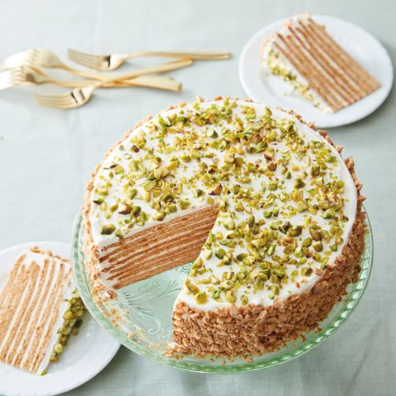

8-Layer Honey-Pistachio Cake
William Sonoma

Write a review. This action will redirect to login page
Prep Time: 60 minutes
Cook Time: 20 minutes
Servings: 12
This impressive cake—which hails from Russia—has eight delicate, honey-infused layers that are made from a cookie-like dough. Once rolled, cut and baked, the layers are sandwiched with a mixture of whipped cream and sour cream, which softens them to a melt-in-your-mouth texture. The cake has a lovely balance of rich honey and tart sour cream. If you prefer a sweeter cake, add an additional 1 cup (4 oz./125 g) confectioners’ sugar to the frosting.

Ingredients:
- For the cake:
- 3 cups (15 oz./470 g) all-purpose flour, plus more for dusting
- 1 tsp. baking soda
- 1/4 tsp. kosher salt
- 1/2 cup (6 oz./185 g) honey
- 1/2 cup (4 oz./125 g) granulated sugar
- 2 Tbs. unsalted butter
- 3 eggs

For the sour cream frosting:
- 1 cup (8 fl. oz./250 ml) heavy cream
- 4 cups (2 lb./1 kg) sour cream
- 2 cups (8 oz./250 g) confectioners’ sugar
- 1 tsp. vanilla extract
- 1/4 tsp. kosher salt
- 1/2 cup (2 oz./60 g) toasted pistachios, chopped

Directions:
To make the cake, preheat an oven to 350°F (180°C). Line a baking sheet with parchment paper.
In a bowl, sift together the flour, baking soda and salt. Set aside. In a large saucepan over medium heat, combine the honey, granulated sugar and butter and cook, stirring occasionally, until the butter melts and the sugar and honey dissolve, about 5 minutes. Remove from the heat and let cool slightly.
In a small bowl, whisk the eggs until blended. Add a small amount of the honey mixture to the eggs and whisk to combine. While whisking constantly, gradually add the egg mixture to the honey mixture in the saucepan. Using a rubber spatula, fold in the flour mixture until almost incorporated, then transfer to a lightly floured surface and knead just to form a disk. Divide the disk into 8 equal pieces.
Roll out each piece of dough into a 9-inch (23-cm) round. Using an 8-inch (20-cm) plate or cake pan for tracing, cut each piece into an 8-inch (20-cm) round, reserving the scraps. Transfer 2 rounds to the prepared baking sheet and bake until crisp and golden brown, about 6 minutes. Transfer to a wire rack and let cool. Repeat with the remaining rounds. The cooled rounds should have the texture of graham crackers. Place the reserved dough scraps in a single layer on the baking sheet and bake until crisp and golden brown, about 6 minutes. Set aside.
To make the sour cream frosting, in the bowl of a stand mixer fitted with the whisk attachment, beat the cream on medium-high speed until stiff peaks form, about 3 minutes. In a large bowl, using a handheld whisk, whisk together the sour cream, confectioners’ sugar, vanilla and salt. Using a rubber spatula, fold in the whipped cream.
To assemble the cake, place 1 cake round on a parchment-lined baking sheet or a cake circle. Spread about 1/2 cup (4 oz./125 g) of the sour cream frosting evenly over the disk, all the way to the edges (it’s okay if some spills over). Top with another cake round and spread with frosting, then repeat with the remaining cake rounds. Spread the remaining frosting evenly over the top and sides of the cake. Using a small food processor, or a plastic bag and a rolling pin, crush the scrap pieces. Press the crumbs onto the sides of the cake. Sprinkle the pistachios over the top.
Refrigerate the cake overnight; the frosting will soften the layers into a cakelike texture. Serve chilled or at room temperature. Serves 12.

