Gâteau Breton with Apricot Filling

101

SERVES8
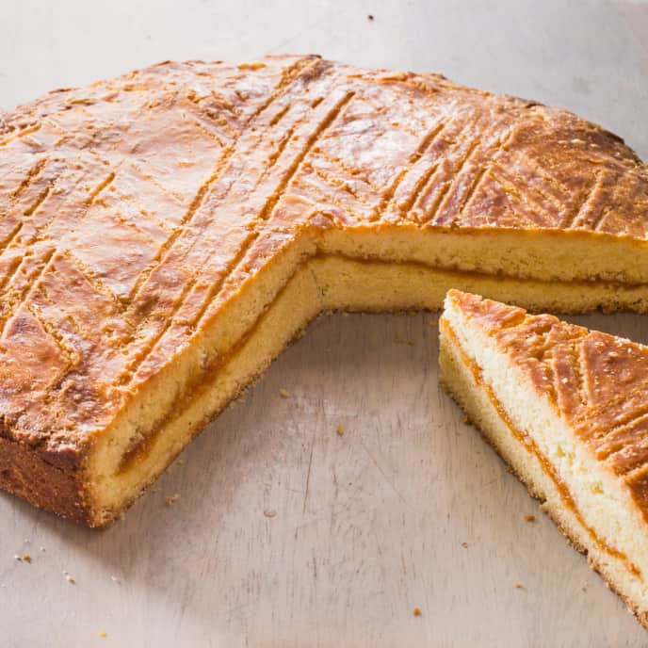

Filling
⅔ cup water
½ cup dried California apricots, chopped
⅓ cup (2 1/3 ounces) sugar
1 tablespoon lemon juice

Cake
16 tablespoons
unsalted butter,
softened
¾ cup plus 2 tablespoons (6 1/8 ounces) sugar
6 large egg yolks (1 lightly beaten with 1 teaspoon water)
2 tablespoons dark rum
1 teaspoon
vanilla extract
2 cups (10 ounces)
all-purpose flour
½ teaspoon Salt
VIEW INGREDIENTS
View Nutritional Informationi

*

BEFORE YOU BEGIN
We strongly prefer the flavor of California apricots in the filling. Mediterranean (or Turkish) apricots can be used, but increase the amount of lemon juice to 2 tablespoons. This cake is traditionally served plain with coffee or tea but can be dressed up with fresh berries, if desired.
1

INSTRUCTIONS
FOR THE FILLING: Process water and apricots in blender until uniformly pureed, about 2 minutes. Transfer puree to 10-inch nonstick skillet and stir in sugar. Set skillet over medium heat and cook, stirring frequently, until puree has darkened slightly and rubber spatula leaves distinct trail when dragged across bottom of pan, 10 to 12 minutes. Transfer filling to bowl and stir in lemon juice. Refrigerate filling until cool to touch, about 15 minutes.
2
FOR THE CAKE: Adjust oven rack to lower-middle position and heat oven to 350 degrees. Grease 9-inch round cake pan.
3
Using stand mixer fitted with paddle, beat butter on medium-high speed until smooth and lightened in color, 1 to 2 minutes. Add sugar and continue to beat until pale and fluffy, about 3 minutes longer. Add 5 egg yolks, one at a time, and beat until combined. Scrape down bowl, add rum and vanilla, and mix until incorporated, about 1 minute. Reduce speed to low, add flour and salt, and mix until flour is just incorporated, about 30 seconds. Give batter final stir by hand.
4
Spoon half of batter into bottom of prepared pan. Using small offset spatula, spread batter into even layer. Freeze for 10 minutes.
5
Spread 1/2 cup filling in even layer over chilled batter, leaving 3/4-inch border around edge (reserve remaining filling for another use). Freeze for 10 minutes.
6
Gently spread remaining batter over filling. Using offset spatula, carefully smooth top of batter. Brush with egg yolk wash. Using tines of fork, make light scores in surface of cake, spaced about 1 1/2 inches apart, in diamond pattern, being careful not to score all the way to sides of pan. Bake until top is golden brown and edges of cake start to pull away from sides of pan, 45 to 50 minutes. Let cake cool in pan on wire rack for 30 minutes. Run paring knife between cake and sides of pan, remove cake from pan, and let cool completely on rack, about 1 hour. Cut into wedges and serve.

