Fresh Strawberry Pie

SAMANTHA SENEVIRATNE
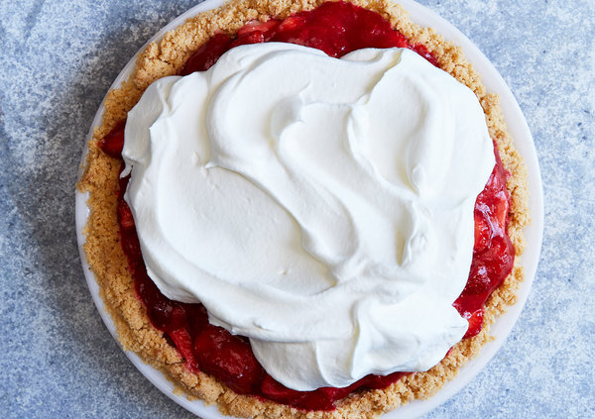
Linda Xiao for The New York Times

INGREDIENTS

FOR THE CRUST:
10 ⅔ ounces/300 grams shortbread cookies (two 5 1/3-ounce packages)
3 tablespoons granulated sugar
1 tablespoon all-purpose flour
¼ teaspoon kosher salt
¼ cup/55 grams unsalted butter, melted

FOR THE FILLING:
2 ½ pounds/about 1 kilogram strawberries (about 8 to 10 cups), hulled
⅓ cup/65 grams granulated sugar
3 tablespoons strawberry preserves
¼ cup/30 grams cornstarch
Pinch of kosher salt
1 tablespoon fresh lemon juice

FOR THE TOPPING
1 cup/240 milliliters cold heavy cream
1 tablespoon confectioners’ sugar
½ teaspoon pure vanilla extract (optional)

PREPARATION
Prepare crust: Heat oven to 350 degrees. In a food processor, combine shortbread cookies, sugar, flour and salt and blend until you have fine crumbs. Transfer crumbs to a medium mixing bowl. Add butter and mix with a fork until crumbs are evenly moistened. Tip crumbs into a standard 9-inch pie plate and press them in an even layer on the bottom and up the sides of the plate. Bake until golden brown and set, 15 to 20 minutes. Transfer to a rack to cool completely.
Prepare filling: Cut each of the strawberries in quarters or eighths, if they are large. Transfer 2 cups berries to a small saucepan and crush completely with a potato masher. Set aside the remaining berries in a large bowl. Add the sugar, preserves, cornstarch, 1 tablespoon water and salt to the saucepan.
Bring strawberry mixture to a boil over medium heat and then cook it an additional 2 minutes, stirring constantly. Add strawberry mixture and lemon juice to the strawberries in the bowl and stir to combine. Transfer to the prepared crust and gently tap it down into an even layer. Transfer to the fridge to set for at least 4 hours.
Just before serving, whip cream, confectioners’ sugar and vanilla, if using, to soft peaks. Top pie with whipped cream.

