Fettuccine With Asparagus And Smoked Salmon

FLORENCE FABRICANT

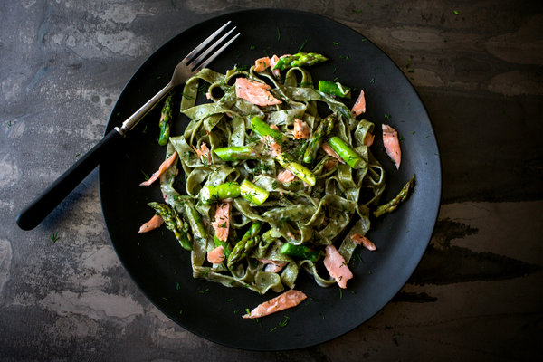

½ pound fresh asparagus, medium thickness
Salt
1 tablespoon butter
½ tablespoon minced shallots
1 cup heavy cream
4 ounces smoked salmon sliced 1/4-inch thick
Freshly ground black pepper
1 teaspoon fresh lemon juice
9 to 10 ounces fresh green fettuccine noodles
2 tablespoons minced fresh dill

Snap off the ends of the asparagus where they break naturally and peel the stalks. Cut the asparagus on a slant to pieces about an inch long.

Steam the asparagus until they are just barely tender and still bright green, about three minutes. Rinse under cold water, drain well on paper towels and set aside.

Bring a large pot of salted water to a boil for the pasta.

While the water is coming to a boil, melt the butter in a large heavy skillet. Add the shallots and saute until soft but not brown. Stir in the cream and simmer about five minutes, until the cream has thickened somewhat.

Cut the salmon into slivers, add it to the cream and remove the skillet from the heat. Season with pepper and lemon juice. Add the asparagus.
When the pot of water is boiling, add the fettuccine, stir it once or twice, then cook two to three minutes after the water has returned to a boil. Drain well.
Briefly reheat the sauce. Transfer the fettuccine to a warm serving bowl, pour the sauce over it and toss. Sprinkle with dill and serve.

