Eye of the Komodo

ROSIE SCHAAP

- YIELD4 drinks
Save To Recipe Box
Print this recipe
Share on Facebook Share on Pinterest Share on Twitter Email
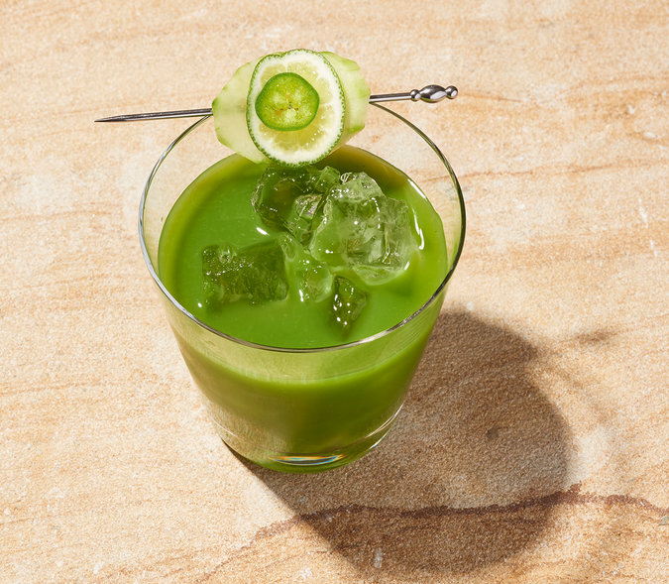
Davide Luciano for The New York Times. Food stylist: Maggie Ruggiero. Prop stylist: Gozde Eker.
My friend Michael Sharkey is one of the best home bartenders I know, and he sometimes surprises me with delicious new creations when I visit. His latest is the Eye of the Komodo (he originally christened it Ojo del Komodo — but I botched and Anglicized it, probably because I think the Eye of the Komodo sounds more like a ‘60s horror movie). Built on a foundation of what Michael calls “lizard liquid” and fortified by mezcal, it is bright green, satisfyingly spicy and garnished with a vegetal “eyeball.” What’s not to love?
Featured in: How Sex, Animals And Obama End Up In Drink Names.
Jalapeno, Cucumber, Cilantro, Mezcal
Cooked

15 ratings

INGREDIENTS

FOR THE “LIZARD LIQUID":
- 1 large cucumber peeled and cut into big chunks (save 4 slices for garnish)
- 1 handful cilantro
- ½ a jalapeño, with most of the seeds removed (save 4 slices for garnish)
- 8 ounces mezcal
- 8 ounces "lizard liquid"
- 2 ounces fresh lime juice (save 4 slices of lime for garnish)
- 2 scant tablespoon agave nectar

PREPARATION
- First, prepare the “lizard liquid": Combine cucumber chunks, cilantro and jalapeño in a food processor until completely liquefied. Strain through a fine-mesh strainer.
- In a cocktail shaker filled with ice, combine mezcal, "lizard liquid," lime juice and agave nectar.
- Fill 4 glasses with ice, shake the mixture and pour over the ice. Garnish with layered cucumber, lime and jalapeño slices, held together with a toothpick. (Those are the lizard eyes). Dust with chile powder.
Have you cooked this? Mark as Cooked

