Eggplant With Lamb, Tomato and Pine Nuts

MELISSA CLARK

- Yield8 servings

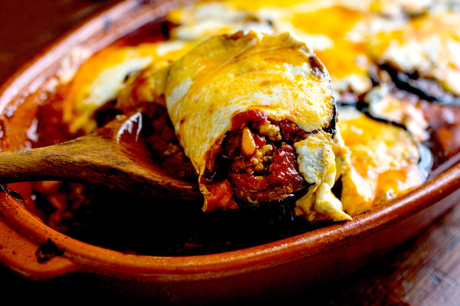
Andrew Scrivani for The New York Times
With its layers of golden eggplant, cinnamon-scented lamb, and sweet tomato sauce topped with melted cheese, this traditional Lebanese dish is made for celebratory meals and gatherings. Even better, it’s just as good served warm or room temperature as it is hot from the oven. It also reheats well, meaning that you can bake it the day before, and reheat it before serving if you like. Pull it out of the refrigerator, let it come to room temperature for an hour, then reheat it covered for about 40 minutes at 350 degrees.
Featured in: Maureen Abood’s ‘Rose Water & Orange Blossoms’ Takes You To Lebanon.
- 2 large firm eggplants, cut into 1/2-inch slices
- 4 tablespoons extra-virgin olive oil
- 2 teaspoons kosher salt, more as needed
- 1 medium yellow onion, finely diced
- 2 garlic cloves, minced
- 1 pound ground lamb or beef (80 percent lean)
- ½ teaspoon ground cinnamon
- Black pepper
- ½ tablespoon unsalted butter
- ½ cup pine nuts
- 1 (28-ounce) can tomato sauce, or 31/2 cups homemade sauce (see recipe)
- 12 ounces fresh mozzarella, sliced

Nutritional Information

PREPARATION
- Heat broiler and line a baking sheet with foil or parchment.
- Brush both sides of eggplant slices with 2 tablespoons olive oil and sprinkle with 1 teaspoon salt. Arrange slices on prepared baking sheet and broil in batches until they are deep mahogany brown, turning once halfway through, 5 to 7 minutes per side.
- Adjust the oven to 375 degrees with rack positioned in the center.
- In a large skillet, heat 1 tablespoon of the remaining olive oil over medium heat. Add onion and sauté until translucent, but not browned, stirring occasionally, about 5 minutes. Add garlic and cook until fragrant, about 1 minute. Add ground lamb or beef, stirring frequently and breaking up meat into very small pieces with the side of a metal spoon. Season with remaining teaspoon salt, cinnamon and pepper. Sauté until meat is just cooked through. Taste and add more salt or pepper, or both, as needed.
- In a medium skillet, melt butter over medium heat. Add pine nuts and reduce heat to medium-low. Stir nuts to coat them with butter and continue stirring constantly until nuts are golden brown, 2 to 4 minutes. Keep a close watch over the nuts; they can burn quickly once they begin to brown. Transfer nuts to a bowl while still warm and salt them lightly.
- Coat a 13-by-9-by-2-inch baking dish with remaining 1 tablespoon of olive oil. Spread 1/2 cup of tomato sauce in the bottom of the dish. Lay 1/3 of the eggplant slices in a single layer over the sauce, covering as much surface area of the bottom of the dish as possible. Spoon half the meat evenly over eggplant. Pour 1/3 of the remaining tomato sauce evenly over meat. Sprinkle with 1/3 of the pine nuts. Layer again with eggplant, meat, tomato sauce and pine nuts. Finish with a layer of eggplant and cover with more tomato sauce, sprinkling top with pine nuts.
- Pour 1 cup warm water around the perimeter of the baking dish. (Sauce will thicken as it bakes.) Cover pan with foil and bake for 90 minutes. Remove foil and top eggplant evenly with mozzarella. Bake for 15 minutes longer, uncovered, or until the cheese is bubbling and golden. Serve eggplant warm, over rice.

