Dutch baby pancakes with fried eggs and mushrooms
SERVES
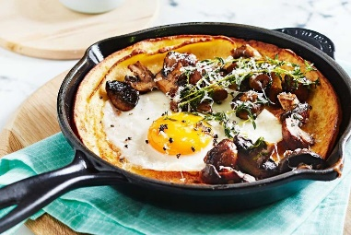

- 1/4 cup (60ml) garlic infused extra virgin olive oil, or extra virgin olive oil
- 150g Swiss brown mushrooms
- 1 tbs thyme leaves, plus extra thyme sprigs to serve
- 2 eggs
- Tomato relish, to serve

DUTCH BABY PANCAKES
- 1/2 cup (75g) plain flour
- 2/3 cup (165ml) milk
- 1 cup (80g) finely grated parmesan
- 20g unsalted butter

- 1.
Place two small ovenproof skillets (or one large ovenproof frypan) in the oven and preheat to 240°C.
- 2.
For the Dutch pancakes, place the eggs, flour, milk and parmesan in a food processor. Season, then whiz for 1 minute or until smooth. Remove pans from oven and divide the butter between the pans to grease. Divide batter between the pans, then immediately return to oven. Bake for 15 minutes or until golden and puffed
- 3.
Meanwhile, heat 2 tbs oil in a frypan over medium-high heat. Add the mushrooms, season, and cook, stirring, for 2-3 minutes until golden. Add thyme and cook, tossing, for a further 1 minute or until fragrant. Remove mushrooms and set aside.
04
- 4.
Add remaining 1 tbs oil to the pan, then carefully crack in eggs and fry until whites are just cooked or until cooked to your liking.
- 5.
Serve Dutch baby pancakes in pans topped with an egg, mushrooms extra thyme sprigs and tomato relish on the side.

