Cubano
Recipe courtesy of Melissa d'Arabian

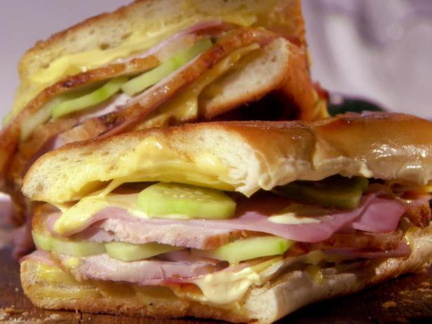

Yield: 4 servings

Ingredients
- 2 tablespoons mayonnaise
- 2 tablespoons Dijon mustard
- 1 large wide loaf French bread (not baguette), halved lengthwise and quartered into 8 small slices
- 8 slices Swiss cheese
- 4 to 6 slices deli-style ham
- 5 to 6 ounces thinly sliced pork (roast, chop or pulled)
- Quick Garlic Pickles, or dill pickles
- 4 tablespoons butter, softened

Directions
Mix the mayonnaise and mustard in a small bowl and spread evenly on the inside of the bread slices. Layer on half of the cheese, the ham, pork, Pickles and the remaining cheese. Cover with another slice of bread and butter the outside (top and bottom) of the sandwich.
Heat a cast-iron skillet to medium-high heat and place the sandwiches in the pan. Top with a second cast-iron skillet to weigh the sandwiches down. After 2 minutes, turn down the heat to medium low, flip the sandwiches and weigh down again with the second skillet. Check the sandwiches after 1 more minute, and remove when golden brown and the cheese has melted.

