Crispy Sour Cream and Onion Chicken

ALI SLAGLE
- YIELD4 servings

Tip: Freezing the chicken breasts for 15 minutes to firm them up will make slicing them through the middle easier.

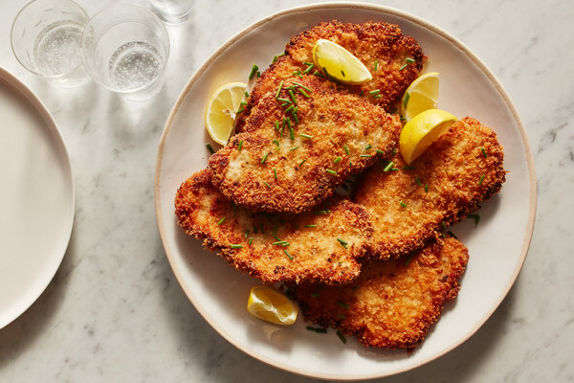
Johnny Miller for The New York Times. Food Stylist: Rebecca Jurkevich.

INGREDIENTS
4 boneless, skinless chicken breasts, halved horizontally (see Tip) and pounded 1/8-inch thick, or use 4 chicken cutlets (don’t split or pound)
Kosher salt and black pepper
½ cup sour cream or Greek yogurt
¼ cup thinly sliced chives (or 1 tablespoon dried chives), plus more for serving
2 tablespoons onion powder
2 cups panko bread crumbs
Canola oil, for frying
1 lemon, cut into wedges

PREPARATION
Pat chicken dry, and season both sides with salt and pepper.
In a medium bowl, stir together the sour cream, chives and 1 tablespoon onion powder. Season with salt and pepper. Add the chicken and turn to coat. (Chicken can sit in the marinade for up to 8 hours. Refrigerate, then let come to room temperature before cooking.)
In a shallow bowl or lipped plate, stir together the panko and remaining 1 tablespoon onion powder; season with salt and pepper.
Working one at a time, press the chicken breasts into the panko, using your fingers to pack the panko onto both sides of the chicken, and place on a large plate or a sheet pan.
Line a plate with paper towels. Heat 1/8-inch canola oil in a large skillet over medium-high. Drop a piece of panko in: If it sizzles, the oil’s ready. Add a chicken cutlet (or two, if they can fit comfortably), and cook until golden brown, 3 to 5 minutes per side. Transfer to the paper towel-lined plate and sprinkle with salt. Repeat with remaining chicken, adding and heating more oil as needed, and removing excess panko from the pan with a slotted spoon.
Serve chicken with more chives and lemon wedges for squeezing.

