Crispy Chicken-Nugget Meatballs

By Ali Slagle
- YIELD24 meatballs
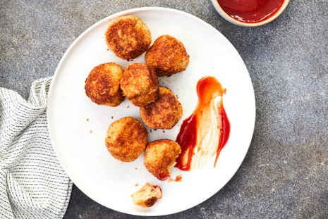

- 1 ¾ cups panko bread crumbs
- ½ cup whole milk
- 1 large egg
- 1 teaspoon garlic powder
- Kosher salt (Diamond Crystal)
- 1 pound ground chicken or turkey
- 1 cup finely grated Parmesan
- 4 tablespoons unsalted butter
- 2 tablespoons olive oil
- Serve with ketchup

- In a large bowl, combine 1 cup panko, the milk, egg, garlic powder and 1 teaspoon salt. Stir together and let sit for 5 minutes.
- Add the chicken and 3/4 cup Parmesan. Stir with your hands until combined, avoiding overmixing. Roll into 24 balls about the size of a golf ball (about 2 tablespoons each) and place on a sheet pan or plate. In a medium bowl, stir together the remaining ¾ cup panko and ¼ cup Parmesan. Toss each meatball in the panko-cheese mixture, pressing gently to adhere. (To avoid a big mess, designate one “wet hand” for touching the meatballs and one “dry hand” for tossing in the panko.) Refrigerate for 5 minutes.
- In a large (12-inch) skillet, heat 2 tablespoons butter and 1 tablespoon oil over medium. When foaming, add half the meatballs. Cook, turning often and reducing the heat if needed to prevent burning, until golden brown and cooked through, 7 to 10 minutes. Transfer to a plate.
- Reduce the heat to medium-low and remove any dark oil or loose panko from the skillet with a spoon or paper towel. (The skillet will be hotter at this point, so reducing the heat ensures even cooking for both batches.) Add the remaining 2 tablespoons butter and 1 tablespoon oil. When foaming, add the remaining meatballs and cook, turning often, until golden brown and cooked through, 7 to 10 minutes. Transfer to the plate.

