Coconut Pumpkin Soup
by Anne-Marie Nichols of This Mama Cooks
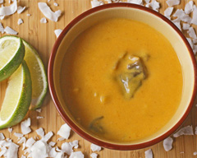
0
There?s always a can or two of pumpkin puree leftover from Thanksgiving, so here’s a suggestion on how to use it up after the holidays.
This soup combines the canned pumpkin with ingredients traditionally found in Thai coconut soup.

Serving Size
8

Ingredients
- 1 teaspoon olive oil
- 1 small onion, diced
- 1 large clove garlic, minced
- 1 can (15 ounces) pumpkin puree
- 1 can (13.5 ounces) light coconut milk
- 1 teaspoon dried lemon grass
- ½ teaspoon fresh ginger, grated
- ½ to 1 teaspoon chili sauce, plus extra for serving
- ½ teaspoon soy sauce
- ½ tablespoon lime juice
- 1 can (15 ounces) of straw mushrooms, drained
- Slices of lime (optional)

Method
Heat olive oil in a saucepan over medium-low heat.
Add diced onion and minced garlic and cook until onions start to caramelize.
Add remaining ingredients except for mushrooms. Heat over medium-high heat, stirring occasionally, until soup is almost to the boiling point.
Add mushrooms and lower heat. Cook until mushrooms are heated through.
Serve with lime slices and extra sriracha sauce.

