Chicken Mafe

FRANCIS LAM

- YieldServes 6 to 8
Save
Add to a collection
Share on FacebookShare on PinterestPrint this recipe
More
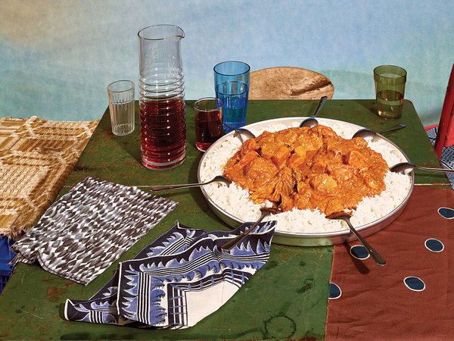
Grant Cornett for The New York Times. Food stylist: Maggie Ruggiero. Prop stylist: Theo Vamvounakis.
This West African favorite, adapted from Rama Dione and Papa Diagne, balances the richness of peanut butter with tomato and aromatics, cooked down to a thick gravy. The addition of Southeast Asian fish sauce gives the dish depth and is somewhat traditional, given the Vietnamese influence, via the French, in Senegal. But absolutely traditional would be to eat this with guests, directly from a large platter, to demonstrate welcome and unity.
Featured in: The Generosity In Senegalese Stew.
Chicken, Fish Sauce, Green Cabbage, Peanut Butter, Scotch Bonnet Chile, African
Cooked

74 ratings

INGREDIENTS
- 12 cloves garlic
- 1 1-inch piece of ginger, peeled
- Kosher salt and black pepper
- Crushed red-pepper flakes
- 2 pounds bone-in chicken, skin removed
- 6 tablespoons vegetable oil
- 1 medium onion, diced
- 3 tablespoons fish sauce
- 6 ounces tomato paste
- 1 cup creamy unsweetened peanut butter
- ½ pound green cabbage, cut into 2-inch wedges
- 3 medium carrots, peeled, cut in 2-inch lengths
- 1 medium sweet potato
- 12 ounces waxy potatoes, like Yukon Gold
- Scotch Bonnet chile slices, to taste (optional)
- White rice, cooked, for serving

Nutritional Information

PREPARATION
- Finely mince 6 cloves garlic and the ginger with a pinch of salt, plenty of black pepper and crushed red-pepper flakes to taste. Season chicken all over with salt, and rub with the garlic mixture. Marinate for three hours or overnight, refrigerated.
- Finely chop the remaining 6 cloves of garlic. In a large Dutch oven, heat the oil over medium-high heat. When it is hot, add the onion, chopped garlic, 2 teaspoons kosher salt and cook, stirring, for 3 minutes, until the onion is starting to become translucent. Stir in the fish sauce, then the tomato paste, and cook, stirring, for 3 minutes, until the paste and onions have combined and are a shade darker. Stir in 6 cups water, scraping up any browned bits.
- Add the chicken, bring to a boil and turn heat down to a moderate simmer. In a mixing bowl, stir a cup of the cooking liquid into the peanut butter, a splash at a time, to loosen it. Pour the peanut butter mixture into the pot, and simmer for 20 minutes. Add the cabbage and carrots, and simmer 10 minutes. Peel and cut the sweet potato and waxy potatoes into 1 1/2-inch chunks, add them and simmer 30 minutes, until the vegetables and chicken are tender and the sauce is like a very thick gravy. (The oil will be separating in the sauce.) If the chicken and vegetables are tender but the sauce is still a little loose, remove them, and let the sauce cook down. Add the chile if using. Taste, adjust seasoning with salt and serve over white rice.
NOTES

