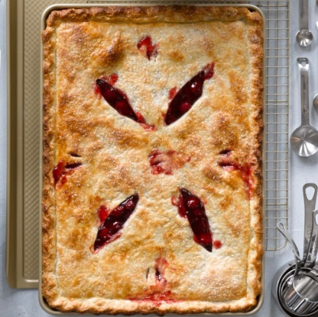
Cherry Slab Pie Williams-Sonoma
Close
Print
If you prefer your pie with lots of filling and less crust, try making a slab pie, a shows topping dessert that’s perfect for serving large group . Both fresh and frozen cherries work well in this recipe, but if you’re using frozen, be sure to drain them after defrosting to prevent the juice from turning your pie soggy.

Ingredients:

For the dough:
- 5 cups (25 oz./780 g) all-purpose flour
- 1/4 cup (2 oz./60 g) granulated sugar
- 1 1/4 tsp. salt
- 32 Tbs. (4 sticks) (1 lb./500 g) cold unsalted butter, cut into 1/2-inch (12-mm) dice
- 8 to 10 Tbs. (4 to 5 fl. oz./125 to 155 ml) ice water

For the filling:
- 7 cups (2 3/4 lb./1.25 kg) pitted fresh or thawed frozen cherries
- 3/4 to 1 cup (6 to 8 oz./180 to 250 g) granulated sugar
- 3 Tbs. tapioca starch
- 2 tsp. grated lemon zest
- 1 tsp. almond extract
- Pinch of salt
- 1 egg lightly beaten with 1 tsp. water
- 1 Tbs. coarse sugar (optional)

Directions:
To make the dough, in a food processor, pulse together the flour, sugar and salt until combined, about 5 pulses. Add the butter and process until the mixture resembles coarse meal, about 10 pulses. Add 8 Tbs. of the ice water and pulse 2 or 3 times. The dough should hold together when squeezed with your fingers but should not be sticky. If it is crumbly, add more water 1 tsp. at a time, pulsing twice after each addition. Turn the dough out onto a work surface, divide in half and shape each half into a disk. Wrap the disks separately in plastic wrap and refrigerate for at least 2 hours or up to overnight.
Position a rack in the lower third of an oven and preheat to 400°F (200°C
On a lightly floured work surface, roll out 1 of the dough disks into a 22-by-18-inch (55-by-45-cm) rectangle about 1/8 inch (3 mm) thick. Roll the dough around a rolling pin and unroll it on top of a baking sheet. Gently press the dough into the bottom and sides of the pan. Trim the edges, leaving a 1/2-inch (12-mm) overhang.
To make the filling, in a large bowl, toss together the cherries, 3/4 cup (6 oz./185 g) of the sugar, the tapioca starch, lemon zest, almond extract and salt. Taste and add up to 1/4 cup (2 oz./60 g) more sugar if desired. Transfer to the dough-lined pan.
Roll out the remaining dough disk into another 22-by-18-inch (55-by-45-cm) rectangle. Roll the dough around a rolling pin and unroll over the filling. Fold the top crust underneath the edge of the bottom crust and press together to seal. Flute or decorate the edge of the crust as desired. Using a sharp knife, cut several slits in the top crust. Brush the crust with the beaten egg mixture and sprinkle with the coarse sugar.
Bake until the crust is golden and the filling is bubbling, about 45 minutes, tenting with aluminum foil if needed to prevent the top from browning too quickly. Transfer the pan to a wire rack and let the pie cool for at least 1 hour before slicing and serving. Serves 12.
Test Kitchen

