Cheesy White Bean-Tomato Bake

ALI SLAGLE
- YIELD4 servings
- TIME15 minutes
Save to Recipe Box
Print this recipe
EmailShare on PinterestShare on FacebookShare on Twitter
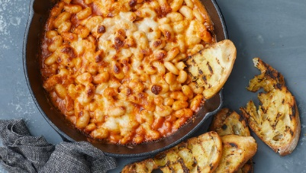
John Kernick for The New York Times. Food Stylist: Simon Andrews.
Here, it’s white beans, though you could add in kale, noodles, even roasted vegetables. Then, all that’s left to do is dot it with cheese and bake until it’s as molten or singed as you like. Serve with bread and a bitter-green salad.
Beans, Mozzarella, Tomato Paste, White Bean, Dinner, Lunch, Weekday, Weeknight, Main Course, Side Dish, Vegetarian

INGREDIENTS
- ¼ cup extra-virgin olive oil
- 3 fat garlic cloves, thinly sliced
- 3 tablespoons tomato paste
- 2 (15-ounce) cans white beans (such as cannellini or Great Northern) or chickpeas, drained and rinsed
- ½ cup boiling water
- Kosher salt and black pepper
- ⅓ pound mozzarella, coarsely grated (about 1 1/3 cups)
Add to Your Grocery List

PREPARATION
- Heat the oven to 475 degrees. In a 10-inch ovenproof skillet, heat the olive oil over medium-high heat. Fry the garlic until it's lightly golden, about 1 minute. Stir in the tomato paste (be careful of splattering) and fry for 30 seconds, reducing the heat as needed to prevent the garlic from burning.
- Add the beans, water and generous pinches of salt and pepper and stir to combine. Sprinkle the cheese evenly over the top, then bake until the cheese has melted and browned in spots, 5 to 10 minutes. If the top is not as toasted as you’d like, run the skillet under the broiler for a minute or 2. Serve at once.

