Carne Asada Cheese Fries

JULIA MOSKIN
- YIELD4 to 6 servings
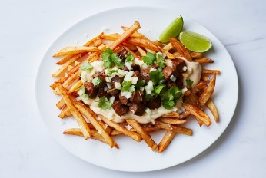
Con Poulos for The New York Times. Food Stylist: Donna Hay.

INGREDIENTS

FOR THE CARNE ASADA:
¾ pound skirt steak or flank steak, cut into 1/2-inch cubes
1 ½ tablespoons lime juice (from 1 lime)
1 tablespoon chili powder
¼ teaspoon ground cayenne (optional)
¾ teaspoon kosher salt
¼ teaspoon black pepper
1 tablespoon neutral oil

FOR THE BEER CHEESE:
- 4 ounces cream cheese, cubed
⅓ cup beer (preferably a lager or other beer without a pronounced flavor)
2 cups finely shredded sharp Cheddar (about 8 ounces)
½ teaspoon Worcestershire sauce
½ teaspoon Dijon mustard
¼ teaspoon garlic powder
¼ teaspoon smoked or sweet paprika
Kosher salt, to taste

FOR SERVING:
½ cup finely chopped yellow or white onion
½ cup chopped fresh cilantro leaves
1 tablespoon fresh lime juice, plus wedges for serving
1 ½ pounds homemade French fries or any fresh or frozen fried potato variety, such as home fries, waffle fries, curly fries or tater tots
Crema Mexicana or sour cream (optional)

PREPARATION
Add steak to a medium bowl, and toss with the lime juice, chili powder, cayenne (if using), salt and pepper until thoroughly coated. Let marinate at room temperature while you prepare the remaining components.
Prepare the beer cheese: In a medium saucepan, melt the cream cheese over medium heat, stirring frequently, about 2 minutes. Add the beer in a slow stream, whisking until smooth. Let the foam die down, about 1 minute, then decrease heat to low and add the cheese one handful at a time, whisking until smooth before adding the next. Once you’ve integrated all the cheese, whisk in the Worcestershire, mustard, garlic powder and paprika. Season to taste with salt, cover and set aside, off heat. (Makes 1 1/4 cups.)
Prepare the garnish: In a small bowl, stir together the onion, cilantro and lime juice. Set aside.
Make the carne asada: Heat the oil in a large cast-iron skillet or griddle over medium-high. Add the meat, and cook, stirring occasionally, until browned and the sauce reduces to a glaze, 3 to 5 minutes.
Arrange cooked fries on a serving platter in an even layer, and drizzle beer cheese on top to taste. Top with the carne asada and onion-cilantro mixture. Serve with lime wedges, and crema, if desired.

