Caramelized Onion Galette

By Sue Li
- YIELD6 to 8 servings
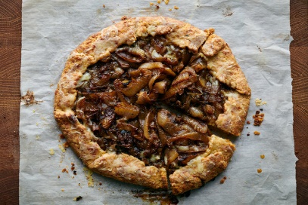
The dish is great for entertaining — it can be prepared in advance — but requires a little bit of patience: You’ll need to let the dough rest for at least four hours, which allows the flour to hydrate and will make the dough less crumbly to work with. Let the tart rest for about 10 minutes before slicing and serving. Eat it while it’s hot or serve at room temperature alongside a salad or steak. Whenever caramelizing sweet onions, always go big (softball). If you've made too much for this recipe you'll have yummy onions for a grilled cheese sandwich.

FOR THE DOUGH:
- 1 ½ cups/190 grams all-purpose flour
- 2 tablespoons granulated sugar
- Kosher salt and black pepper
- ½ cup/115 grams unsalted butter (1 stick), cut into 1/2-inch cubes
- 1 ⅓ cups/4 ounces grated Gruyère
- ¼ cup ice water

FOR THE ONIONS AND ASSEMBLY:
- ¼ cup/55 grams unsalted butter (1/2 stick)
- 4 large sweet onions, peeled and sliced into 1/2-inch rings
- 4 fresh thyme sprigs, plus more fresh thyme leaves for serving
- Kosher salt and black pepper
- 1 cup beef broth (or vegetable broth)
- ¼ cup dry sherry

PREPARATION
- Prepare the dough: In a large bowl, whisk together flour, sugar, 1 1/2 teaspoons kosher salt and 1 1/2 teaspoons black pepper. Add butter and 1 cup grated Gruyère to the flour mixture and toss to coat. Using your fingertips, pinch the butter and cheese into the flour to make pebble-size pieces. Drizzle in the ice water and stir to make a shaggy dough. Dump the dough onto a large sheet of plastic wrap and knead a few times to combine. Wrap in plastic and refrigerate for at least 4 hours.
- Prepare the onions: In a large skillet, melt the butter over medium-high heat. Add onions and thyme sprigs, season with 1 teaspoon salt and 1/2 teaspoon pepper and cook, stirring occasionally, until the onions are translucent and lightly golden on the edges, 20 to 25 minutes. Reduce the heat to medium, add broth and sherry and cook until the onions are browned and the liquid has mostly evaporated but the mixture is still saucy, 16 to 18 minutes. Transfer to a bowl and set aside to cool for at least 30 minutes.
- Heat the oven to 375 degrees. Roll the dough into a 13-inch round on a sheet of parchment. Spread the cooled caramelized onions on the dough, leaving a 1- to 2-inch border. Fold the edges in, over the onions, transfer to a baking sheet and bake until the dough is golden brown and some of the onions have browned on the edges, 40 to 50 minutes, rotating the galette halfway into the baking process.
- Remove galette from the oven and sprinkle remaining 1/3 cup grated Gruyère on the crust. Bake another 5 minutes to melt the cheese. Remove and let rest for 10 minutes before slicing. Top with remaining thyme leaves, for garnish.
Have you cooked this? Mark as Cooked

COOKING NOTES

500

- All272
- Most Helpful42
- Private0
dennis1 year ago

