Brothy Cod With Peas and Mushrooms

By Kay Chun
- YIELD4 servings
- TIME30 minutes
Save to Recipe Box
EmailShare on PinterestShare on FacebookShare on Twitter
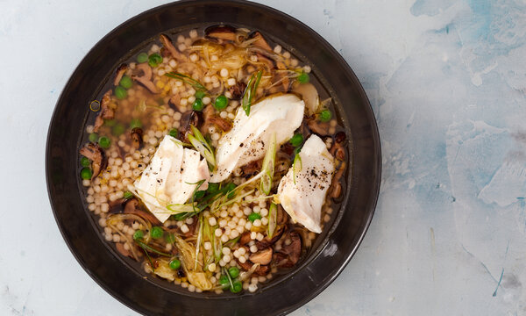
Beatriz Da Costa for The New York Times. Food Styling: Rebecca Jurkevich.

INGREDIENTS
- 3 tablespoons extra-virgin olive oil
- ½ small yellow onion, thinly sliced (about 1/2 cup)
- 3 garlic cloves, thinly sliced
- 2 tablespoons minced fresh ginger
- 6 ounces fresh shiitake mushrooms, stemmed and sliced 1/4-inch thick (about 2 cups)
- Kosher salt and black pepper
- 1 cup pearl couscous
- 1 (8-ounce) bottle clam juice
- 1 ½ pounds skinless cod fillet, cut into 1 1/2-inch pieces
- 1 cup thawed frozen peas
- ¼ cup chopped scallions
Add to Your Grocery List
Ingredient Substitution Guide

PREPARATION
- In a large pot or Dutch oven, heat 2 tablespoons oil over medium. Add onion and cook, stirring occasionally, until softened, about 3 minutes. Add garlic and ginger, and cook, stirring, until fragrant, 1 minute.
- Add mushrooms and the remaining 1 tablespoon oil, and season with salt and pepper. Cook, stirring occasionally, until lightly golden, about 3 minutes. Add couscous and stir until lightly toasted, about 2 minutes.
- Add clam juice and 5 cups water, and bring to a boil over high heat. Reduce heat to medium and simmer until couscous is al dente, about 10 minutes.
- Add cod and peas and bring back to a simmer. Cook, stirring occasionally, until fish is flaky and and cooked through and couscous is tender, about 5 minutes longer. Stir in scallions and season with salt and pepper.
- Divide cod, vegetables and couscous across bowls, and top off with remaining broth. Serve warm.

I found the broth a little lacking so added a teaspoon of miso paste. Seemed a good add.

I used the clam juice as well as two cups of Dashi Bonito stock (from powder). Everyone in the family loved it. It would also be good with some added greens.

I added 2 tbsp dashi, 2 tbsp miso and a dash of soy sauce to augment the flavor. Really nice recipe for a healthy and quick meal.
9 This is helpful

