Braised Lamb With Egg and Lemon

DAVID TANIS

- Yield4 to 6 servings

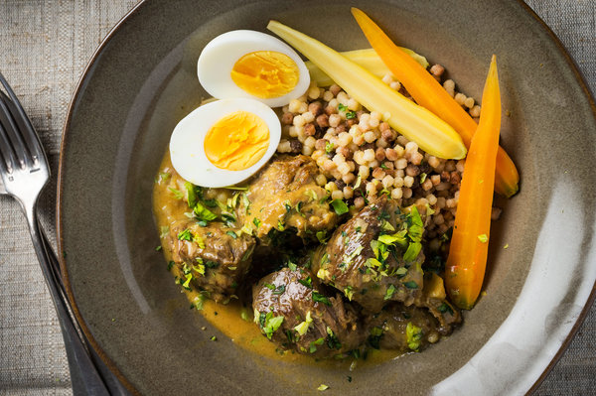
Evan Sung for The New York Times
For a springtime stew, this classic Mediterranean lamb braise is perfect. Tart with lots of lemon juice and enriched with egg yolks, it’s especially good with succulent young lamb. For optimal flavor, it's best to make the stew the night before. Most gourmet food shops and Italian delis sell fregola, a large couscous-like pasta from Sardinia.

INGREDIENTS
- 4 pounds boneless lamb shoulder, cut in 3-inch pieces
- Salt and pepper
- Extra-virgin olive oil
- 1 large onion, diced
- 4 large garlic cloves, chopped
- 2 tablespoons all-purpose flour
- 1 tablespoon tomato paste
- Pinch of saffron, crumbled (optional)
- ½ cup white wine
- 4 cups good chicken broth
- 2 sprigs thyme
- 2 sprigs rosemary
- Bay leaf
- 1 cup fregola, or use Israeli couscous
- 4 egg yolks
- ½ cup lemon juice, plus 1 teaspoon lemon zest
- 3 tablespoons chopped parsley
- 3 tablespoons chopped celery heart leaves
- 4 hard-cooked eggs (8 to 9 minutes) at room temperature, for garnish

Nutritional Information

PREPARATION
- Position a rack in the middle of the oven and heat to 400 degrees. Season lamb pieces generously with salt and pepper. Put 2 tablespoons olive oil in a large Dutch oven or heavy-bottom soup pot over medium-high heat and brown the lamb lightly on each side. (Do this in batches so as not to crowd the pan.) Remove browned lamb from pan and set aside.
- Lower heat to medium, then add onions and cook until soft, allowing them to brown a bit, about 8 to 10 minutes. Add the garlic, flour, tomato paste and saffron, if using, and stir to coat the onions. Stir in wine and broth, then bring to a simmer. Add the browned lamb pieces, thyme, rosemary and bay leaf.
- Cover pot and place on the middle rack of the oven. Bake for 15 minutes, then lower heat to 350 degrees and cook for an additional hour. The meat should be meltingly tender when pierced with a paring knife or skewer.
- Remove lamb pieces with a slotted spoon. Strain cooking liquid through a fine-mesh sieve, then return lamb pieces and strained liquid to the pot. Taste and adjust seasoning. Cool to room temperature, then cover pot and refrigerate overnight; this makes removing the fat easier and improves the flavor.
- Remove the stew from the fridge and remove congealed fat. Place pot over medium heat and bring to a bare simmer.
- Bring a large pot of generously salted water to a boil. Cook fregola until al dente, about 8 to 9 minutes, drain and put into a large serving bowl. Season with salt and pepper to taste, and drizzle with olive oil. Keep warm.
- Just before serving, whisk egg yolks and lemon juice together until well combined. Gradually whisk in some of the hot stew liquid to temper the eggs. Turn off the heat under the stew. Pour egg mixture back into the stew, stirring carefully with a wooden spoon. The sauce will thicken very slightly. Taste for seasoning. (Sauce may curdle if it gets too hot. If necessary, keep stew warm over a double boiler.)
- Transfer stew to a serving dish. Mix together parsley, celery heart leaves and lemon zest, and sprinkle abundantly over the stew. Garnish with peeled and halved hard-cooked eggs. Serve with fregola and, if desired, vegetables such as spring carrots, turnips, asparagus or peas.

