Berry Buttermilk Cake

DAWN PERRY
- YIELD1 (9-inch) square or round cake
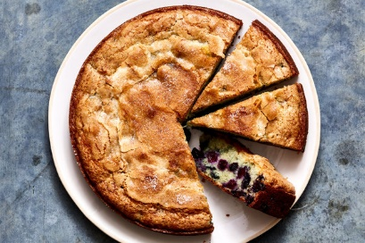

INGREDIENTS
½ cup/120 milliliters vegetable oil or other neutral oil, plus more for greasing the pan
½ cup/120 milliliters buttermilk or milk
2 large eggs
1 tablespoon vanilla extract
1 cup/200 grams plus 2 tablespoons granulated sugar
1 ½ cups/190 grams plus 1 tablespoon all-purpose flour
1 ½ teaspoons baking powder
½ teaspoon baking soda
½ teaspoon kosher salt
1 (10-ounce/285-gram) bag frozen berries (about 2 cups), any kind, any combination (large berries quartered)

PREPARATION
Heat oven to 350 degrees. Brush a 9-inch baking dish or pan (square or round is OK) with oil and line with parchment paper. In a medium bowl, whisk together 1/2 cup oil, buttermilk, eggs, vanilla and 1 cup sugar. In a separate medium bowl, whisk 1 1/2 cups flour, the baking powder, baking soda and salt to combine. Whisk wet ingredients into dry until just combined. (Some small lumps are fine.) Toss berries on a plate with remaining 1 tablespoon flour. Fold into batter and transfer to the prepared baking dish.
Sprinkle evenly with remaining 2 tablespoons sugar. Bake until golden and a toothpick inserted in the middle comes out clean, 53 to 58 minutes. Let cool slightly before serving. Cake will keep, loosely wrapped at room temperature, for about 4 days.

