Basic Pesto Sauce

SAMIN NOSRAT
- YIELD1 2/3 cups
- TIME20 minutes
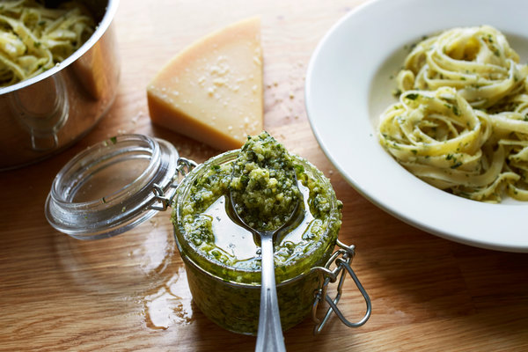
Jessica Emily Marx for The New York Times
The key to making creamy pesto is to add the ingredients to the food processor in the right order to ensure that the nuts break down to a fine paste before the greens have a chance to turn brown. Use basic basil pesto as a pasta sauce, or thin it out with a little olive oil to drizzle it over steak, chicken, fish, pizza or tomato salad. The mint-pistachio variation is inspired by the chef Travis Lett, of Gjelina in Venice, Calif.
Featured in: Five Sauces For The Modern Cook.

INGREDIENTS
- ½ cup pine nuts, lightly toasted
- ¾ cup extra-virgin olive oil
- 2 garlic cloves
- 2 cups packed basil leaves (2 1/2 ounces/75 grams, from 1 big bunch or 2 small bunches)
- 1 cup finely grated Parmesan cheese(3 ounces/85 grams)
- ½ teaspoon kosher salt, more to taste

PREPARATION
- Pulse pine nuts in a food processor until they're completely broken down. Stop to scrape down the sides of the bowl with a spatula from time to time. Add olive oil and garlic and pulse until garlic is finely chopped.
- Chop basil very roughly — just run a knife through it once or twice to cut most of the leaves into halves or thirds — then add to food processor. Pulse, stopping every 15 seconds to push the leaves down with a rubber spatula, until basil is entirely worked into the oil. Pulse for another few seconds, and then stop to prevent turning the basil brown.
- Pour pesto base into a bowl and add grated cheese and salt. Stir to combine, then taste and adjust seasoning as needed. Leave the sauce thick to toss with cooked pasta and a little pasta cooking water. To use the pesto as a garnish for grilled or roasted meats, fish and vegetables, thin it out with 2 to 3 more tablespoons olive oil until it’s the consistency of a loose paste. To store leftovers, pour a little more olive oil over the pesto to cover. Refrigerate in an airtight container for up to three days.

