Baked Brie with Cranberry-Orange Sauce

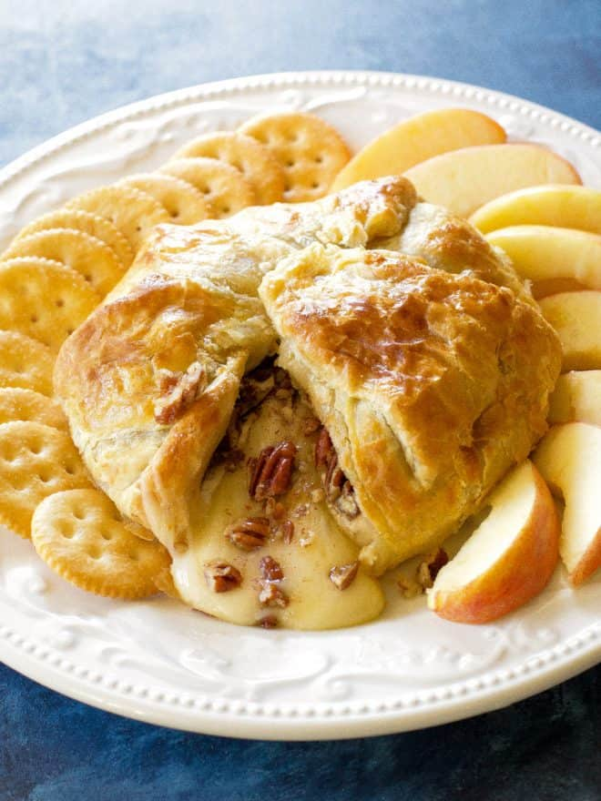
The trick here is to trim the dough as you wrap the brie: Too many layers of overlapping dough and the pastry won’t cook through. This is an excellent make-ahead appetizer since the puff pastry-wrapped brie can be assembled up to a day in advance and stored in the refrigerator.

½ recipe of thick Cranberry-Orange Sauce, flavored with pepper and/or balsamic vinegar

1 sheet puff pastry (about 8 ounces), defrosted and chilled
1 (8-ounce) wheel of brie, freeze for 20 minutes
1 large egg

Baguette slices or crackers, for serving

Freeze the brie for 20 minutes. Slice in half horizontally and spread with a ¼-inch of the cranberry-orange sauce and reassemble. Reserve some sauce for decoration.
Working quickly, unfold the sheet of puff pastry on a lightly floured surface. Using a lightly floured rolling pin, roll it out to an 11-by-11-inch square (the pastry should be about 1/8-inch thick), lifting and rotating the pastry occasionally to prevent sticking. Place the brie in the center of the pastry. Use a paring knife, and leaving a 3 to 3 1/2-inch border, trim the pastry to form a circle around the brie. Discard the scraps or save them for decorating.
In a small bowl, beat the egg with 1 tablespoon water. Brush the pastry border lightly with egg wash, then lift the puff pastry to wrap the brie snugly, one side at a time, trimming the pastry so you don’t have too many overlapping layers. Seal each fold with egg wash. Press all sides of the brie firmly, making sure to tightly seal any seams in the pastry with your hands. Transfer the puff-pastry wrapped brie to a parchment covered sheet pan. Decorate with cut-out pastry, if desired). At this point, if the pastry has warmed up considerably, place the brie in the freezer for 30 minutes to chill before baking. (You can assemble the brie up to this point and refrigerate for up to 24 hours.
Just before baking, brush the whole exterior of the pastry generously with egg wash, then bake until the pastry has puffed and is golden brown, 20 to 35 minutes, rotating the pan halfway through.
Allow to cool for about at least 20 minutes before cutting into it, so the cheese has time to firm up slightly. If desired, decorate the top with a dollop of cranberry-orange sauce. Serve warm with baguette slices or crackers.

